IB Geography Global Interactions – Will COVID-19 Kill Globalization? – Note Taking Frame
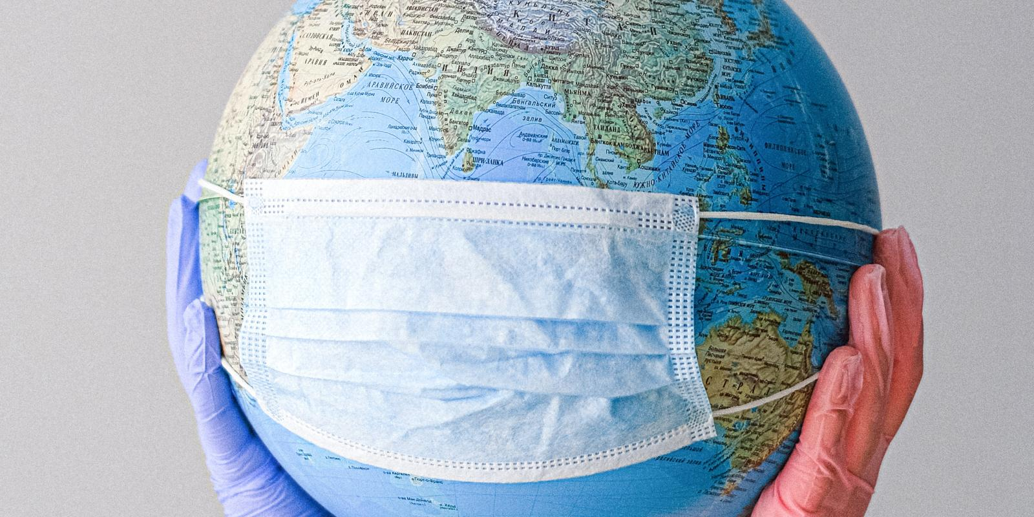
Watch the embedded Economist Video on geographypods and complete note taking around the central image beneath.

