IB Geography – Geophysical Hazard Trends & Future Projections
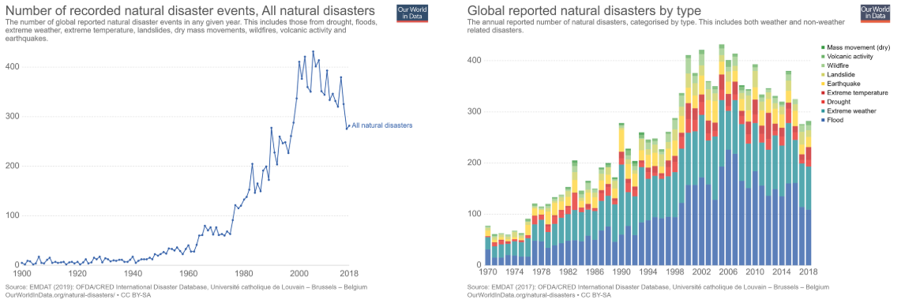
Summary of volcanic activity….

Summary of mass movement activity….

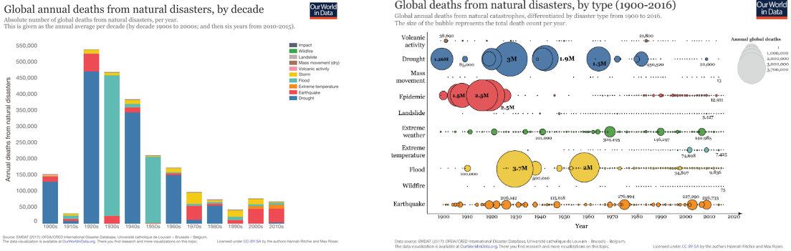

Impacts of future population growth / urbanization…

The global exposure of population and built-up surface to natural hazards increased in the last 40 years. Some hazards, due to their nature and characteristics, pose a threat to a large number of people in different regions of the world.

Earthquake is the hazard that accounts for the highest number of exposed population. The number of people living in seismic areas has increased by 93% in 40 years (from 1.4 billion in 1975 to 2.7 billion in 2015). In 2015, 414 million people lived near one of the 220 most dangerous volcanoes and could suffer from the consequences of eruptions. Tsunamis affect coastal areas in many regions, but dangerous areas are more concentrated in Asia. Japan has by far the highest amount of built-up surface exposed to tsunamis, followed by China and by the United States of America.

