IB DP Geography – Contrasting Resource Security in Switzerland & UAE.
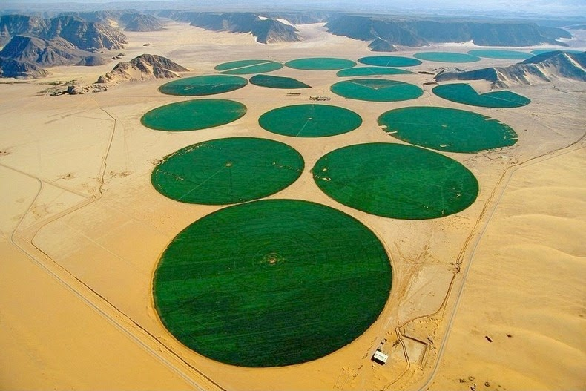
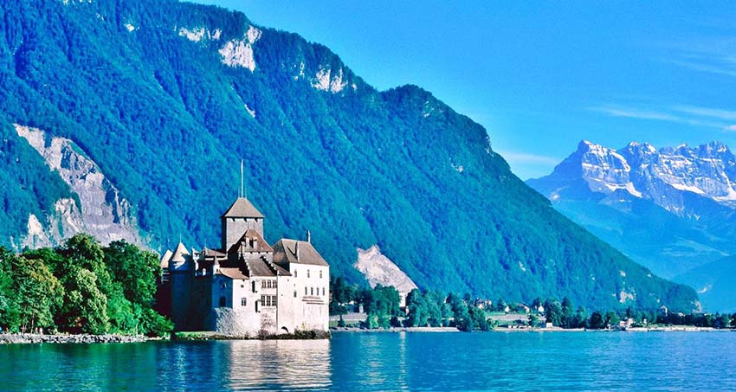
This worksheet compliments the case study and data collection exercise on geographyalltheway.
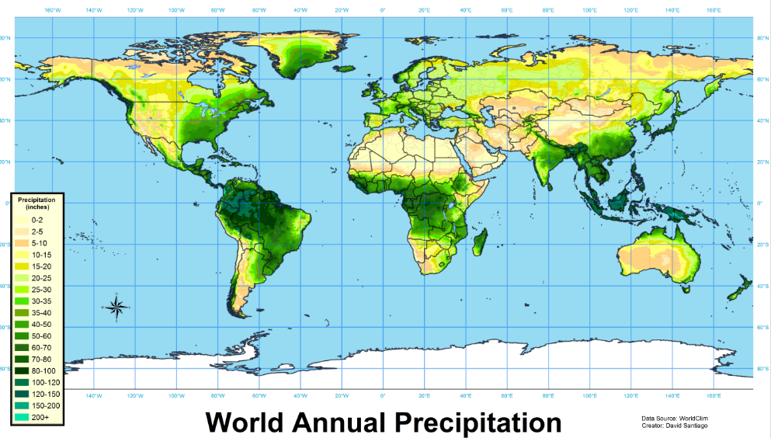
Location. Mark the location of both Switzerland and the UAE on the precipitation map above. Comment in the space below about the contrasting patters of precipitation and what this might mean for food, energy and water security.

You can use the table of links on GATW ( http://www.geographyalltheway.com/in/ib-global-change/03-007-water-food-energy.htm ), or the links here to complete the data and research tasks below:
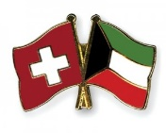 | Switzerland | UAE
 | Key Data
Map | 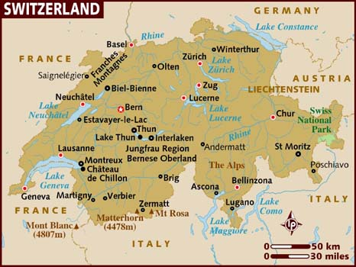 | 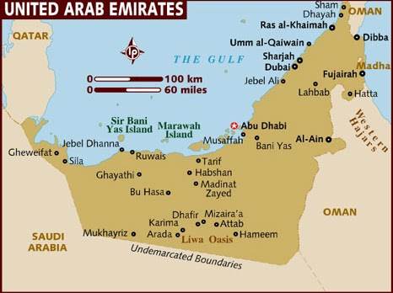
Description of climate & topography of the country (use Google maps)

Income Level

GDP Per Capita $
Total Population & density

Human Development Ranking
Water Security
Current Situation | https://www.swissinfo.ch/eng/thinking-ahead_tapping-into-switzerland-s-future-water-resources/34541266 | https://studies.aljazeera.net/en/dossiers/2015/03/20153318534835257.html
Possibilities |  | https://www.theguardian.com/environment/2016/jan/29/uae-banks-on-rainmakers-to-secure-future-water-supply
Food Security
Current Situation | https://www.swissinfo.ch/eng/directdemocracy/vote-september-24--2017_enshrining-food-security--from-the-farm-to-the-fork/43365026  https://foodsecurityindex.eiu.com/Country/Details#Switzerland | https://www.oxfordbusinessgroup.com/analysis/focus-food-security-gcc-nations-are-working-improve-logistics-and-supply-chains-well-secu-3  https://foodsecurityindex.eiu.com/Country/Details#United%20Arab%20Emirates
Possibilities
Energy Security
Current Situation | https://naturalsciences.ch/topics/water/water_exploitation/water_resources_management/challenges | https://www.thenational.ae/business/uae-energy-security-lies-in-diversification-1.262212
Possibilities

