|  |
| --- |
| Title: |

Study Area

1. Hackescher Market

Study Area

4. Schonhauser Allee

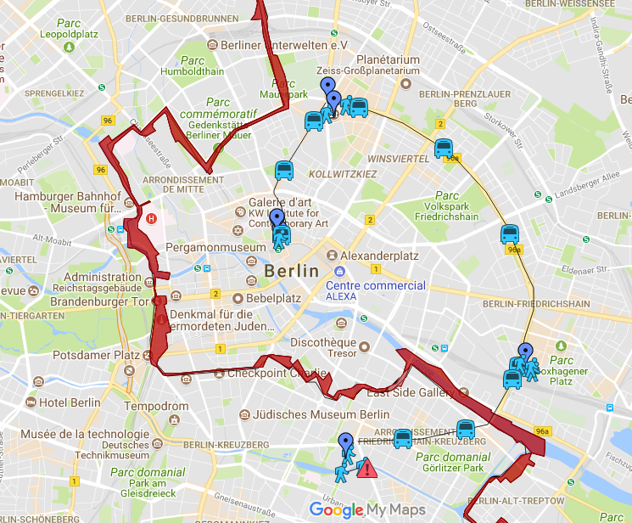

Study Area

3. Courtyard 2 (old)

Study Area

2. Courtyard 1 (new)

Study Area

7. Kottbusser Tor (Turkish Quarter)

Study Area

6. Urban Spree Revaler Str.

Study Area

5. KulturBrauerei