Spatial changes in biomes, habitats and animal migration patterns

Biomes
Place | Process
Power | 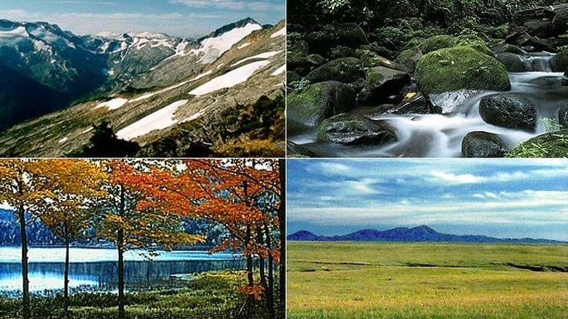  Possibility

Habitats
Place | Process
Power | 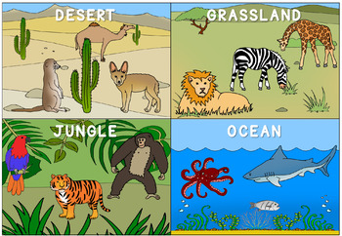  Possibility
Animal Migratory Patterns
Place  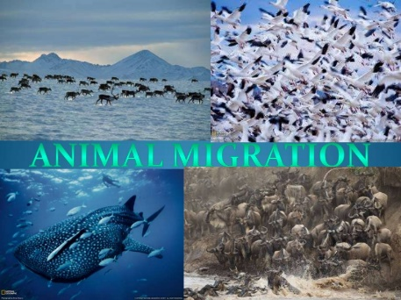 | Process
Power | Possibility

Task 3 - Describe the movements on either of the two maps embedded on ibgeographypods and try to use prior knowledge to explain that movement in particular thinking about where the largest corridors of movement seem to be concentrated, the general direction of movement and linking in to the map showing shifting biomes in the previous section.

