Part 3 – The Food Energy Water Nexus
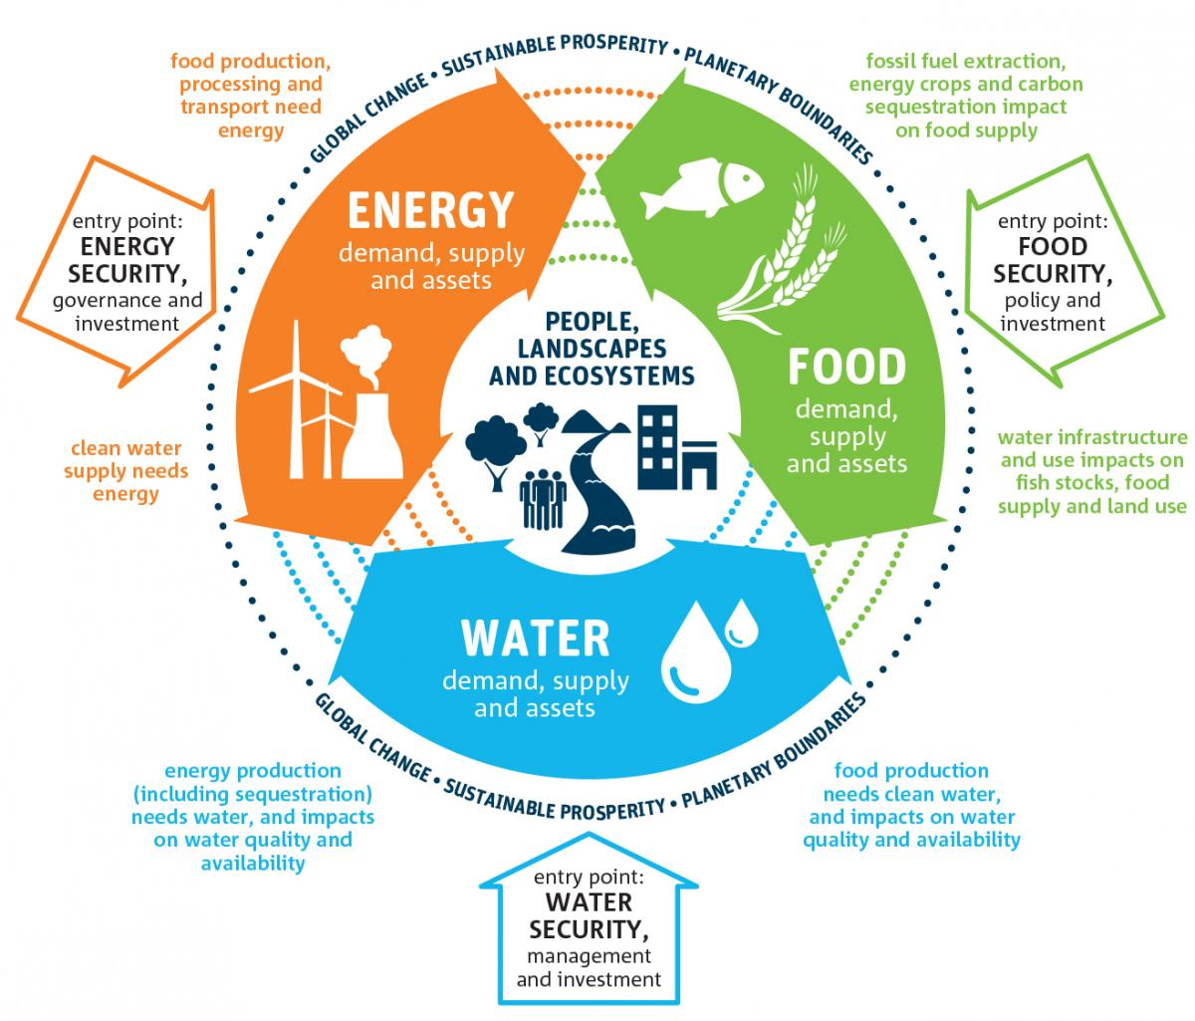

Watch | Read | Listen
www.youtube.com/watch?v=CKW_ux2Xo_w | www.unwater.org/water-facts/water-food-and-energy/ | https://www.bbc.co.uk/sounds/play/p02kbhq0  First 14 minutes

Why do you think is it important to have a Nexus approach (interconnections) rather than view food, energy & water as individual ‘problems to be considered and solved?’

Carry out some research into the Gran Ethiopian Renaissance Dam.
Explain how the project demonstrates Nexus links. Additionally, explain how the project has resulted in global interactions occurring.

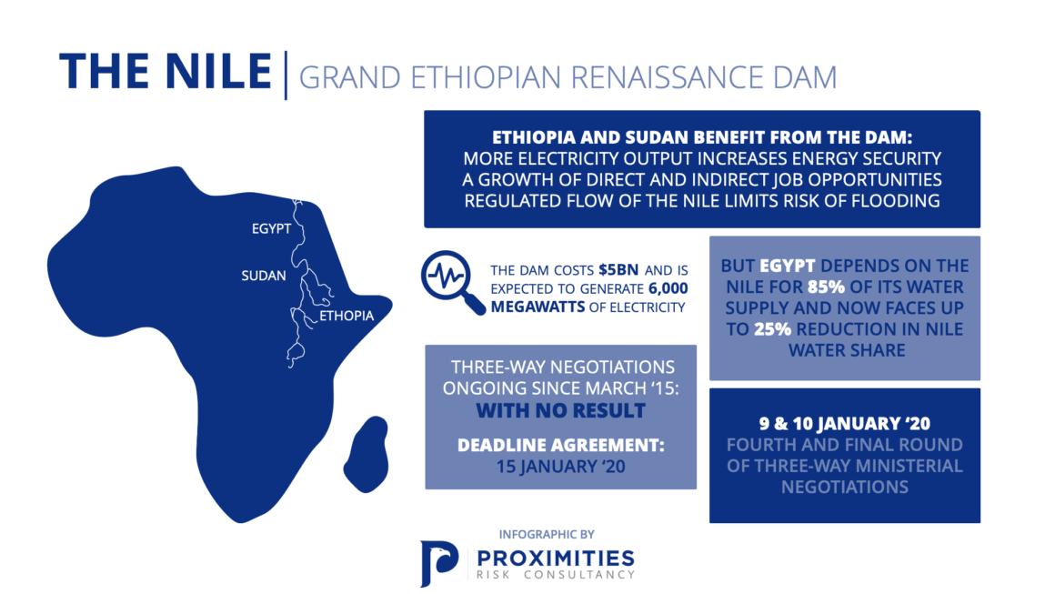
Using the infographic above, identify one positive environmental effect the G.E.R.D will bring.

Carry out some research into biofuel production and so-called land grabs. This link is a good starting point followed by the issues that this places on water supply in this article.
Explain how the biofuel (Energy) production can have detrimental impacts on Food & Water supplies.

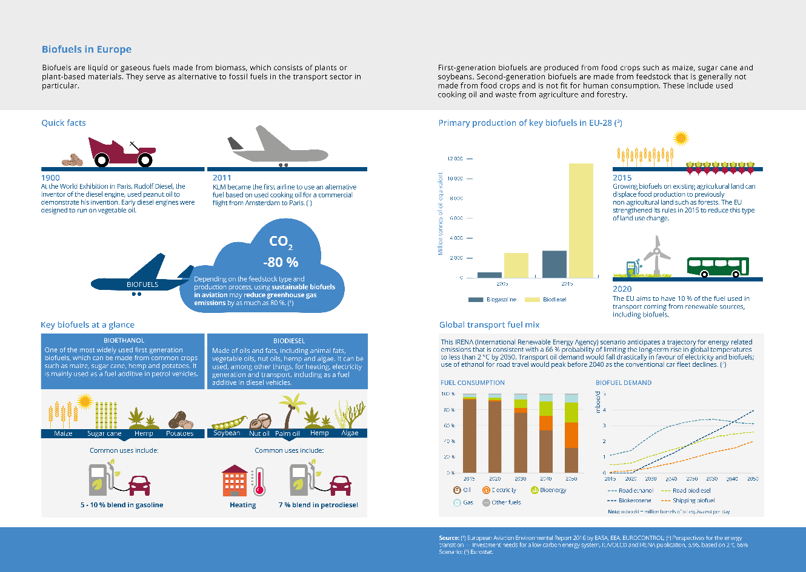
Inspect the graphic above more closely – click here.
According to the fuel consumption chart, which form of energy will have the most significant impact on the reduction of oil power by 2050?

Collaboration Time - Key Questions for Investigation

Working with a partner, each choose a different task (see below) and create a micro presentation to give to them with your response.

You could also work in groups of three.
- Question: To what extent are HICs mostly responsible for the negative effects experienced by those in LICs?
- Question: How can we reverse the effects of water-food-energy insecurities?

- Creative Task – Carefully choose two items from your house. Photograph them and then upload it to a Word document. Annotate around the photo the Nexus connections / implications involved in its manufacture.

Identify the SDG”s below that are most impacted by the Food, Energy, Water Nexus.

