Part 1 – The UN Sustainable Development Goals 2015-2030
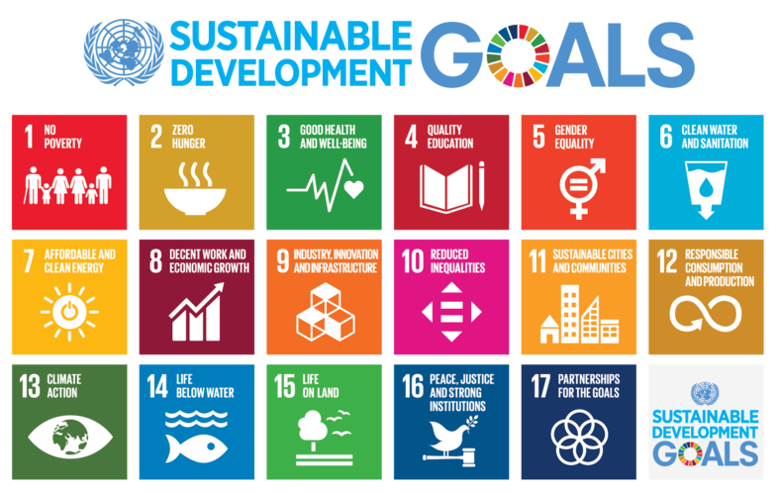

Watch* | Read | Listen*
https://www.youtube.com/watch?v=N3SQlrmV1cE | https://www.theguardian.com/global-development/2015/jan/19/sustainable-development-goals-united-nations | https://www.undispatch.com/podcast-how-much-progress-are-we-making-towards-the-sustainable-development-goals/
*Choose either the watch or listen, depending on how you are feeling.

Key notes from the resources above.

Choose any Goal from the 17 that interest you and conduct a mini investigation (30 mins) into a place in the world where significant progress is being made towards achieving that Goal. Here are a number of projects that you could choose from. Or, you could use a place that you heard about in the video or podcast in the previous task.
Place:
Outline the project and progress being made.

The Grade 11 CAS students (& one Grade 8) at the International School of Toulouse have created an environment group and are raising awareness of the SDG’s through a series events and through their blog here.

https://istenvironment.wixsite.com/istenvironmentgroup/blog – please sign up the site using your school or personal Google account.

Choose three blog posts that interest you linking to three different Goals. You can choose the Goal number by clicking on the link at the top of the page. Some Goals have no posts yet. Read the articles and then comment on the post outlining what you liked and what the article taught you.

Copy those comments into the spaces below.
Article Title, Author & Goal:
Comment

Article Title, Author & Goal:
Comment

Article Title, Author & Goal:
Comment

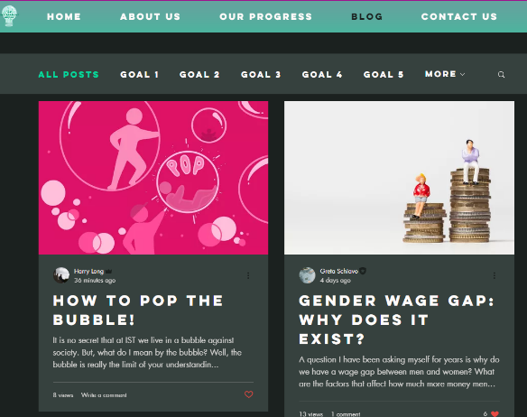

Collaboration Time - Key Questions for Investigation

Working with a partner, each choose a different question (see below) and create a micro presentation to give to them with your response.

You could also work in groups of three.
- How successful do you think the UN will be in achieving the 17 SDGs? Is there anything that could get in the way?

- Is it possible to hold countries accountable for not reaching by these goal targets?

- What evidence of SDG activity can you see in your local environment? (investigation)

