IB DP Geography Geophysical Hazards - Pre-Event Management Strategies

Description of methods including suitability for HIC / LIC | Application in different locations.
Landslides – Slope stabilization & Early Warning Systems  Notes on engineering methods to stabilise slopes.  Listen to the BBC Science in Action Podcast and take notes from 1.00 – 6.00 and make notes on the landslide early warning system and how it might work. | 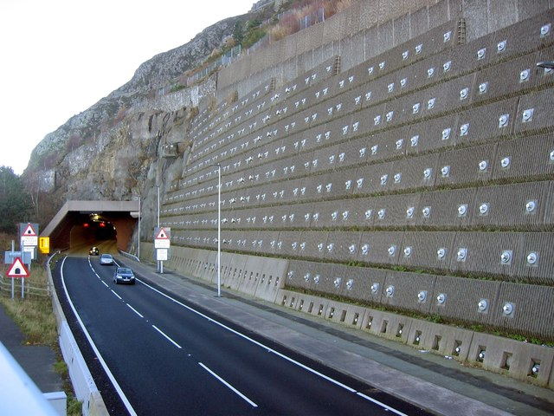
Tsunami Defence – Building a higher Wall in Japan post 2011.  First study the Guardian picture essay by clicking here.  Then, watch the report here and take notes on the new tsunami walls being built on the coastline in Japan and it’s controversies. | 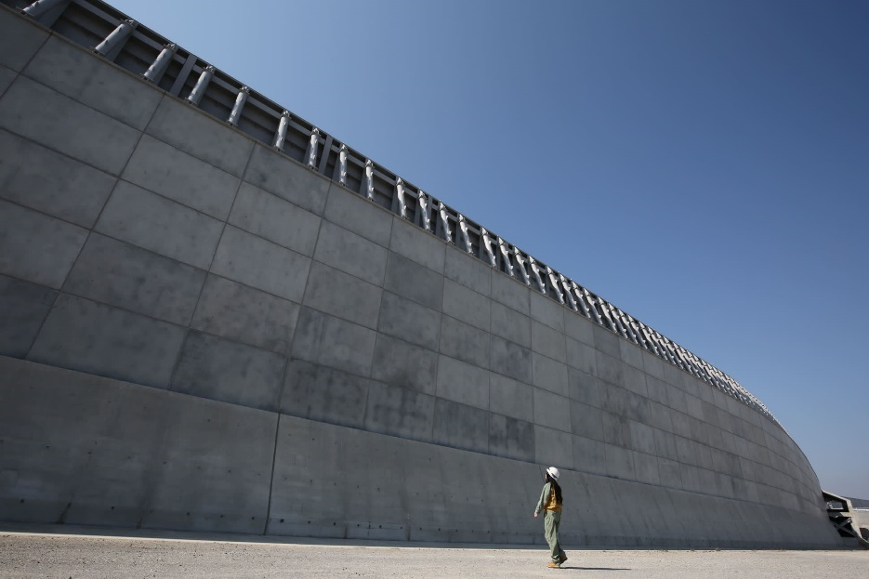
Earthquake Resistant Buildings  Listen to the BBC Inquiry Podcast (2017) Can we Quake-Proof a City?  Part 1 – Lessons from the dead.  Part 2 – High Tech City.  Part 3 – Low Tech city.  Part 4 – Lifelines. | 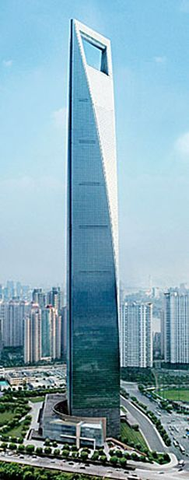  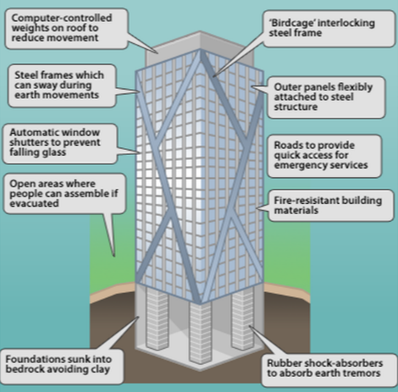 | 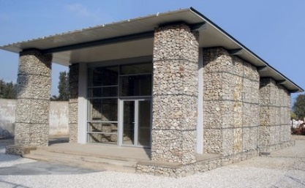  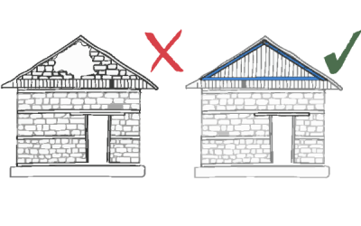  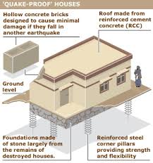  To the left, HIC earthquake resistant building design, and below, LIC.
GPS Crater Monitoring – Volcanoes  Use the excellent information here from USGS to make notes on how GPS crater monitoring can give important warnings about imminent eruptions and how this can reduce vulnerability amongst populations close to the volcano. | 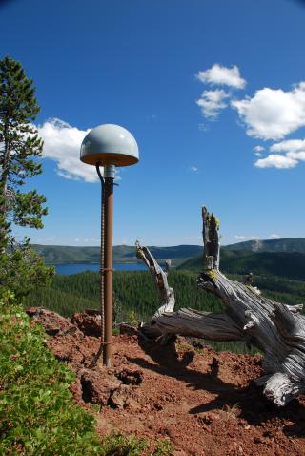  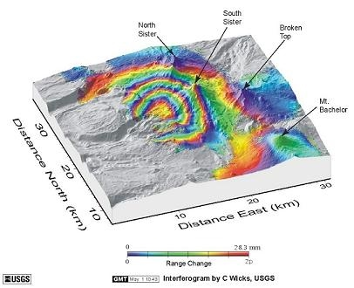  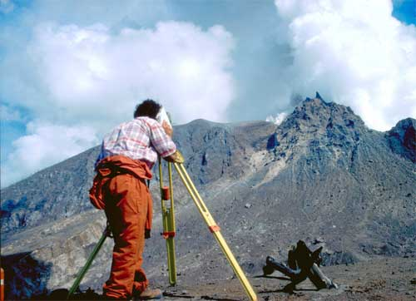
Lava Diversion Channels – Volcanoes  Read the information here and explain how this relatively simple process works. | 