Preparation for IBDP Geography by Paul Goodson

This guide is intended to gently introduce IGCSE students into the content of the IBDP Geography course. Subject teachers will serve as your primary source of information, however there is a major expectation for IBDP students to be much more independent in their approach to learning.

There are five approaches to learning (developing thinking skills, social skills, communication skills, self-management skills and research skills) that encompass the key values and principles that underpin IB Geography. You will progressively excel in these areas in the course of the next two years.

“Geography is the only subject that has given me the skills to interpret and understand reality in a way I could not imagine before and that will remain for life.”

A student at the British School of Rio de Janeiro (2013)

This guide will provide you with an insight to some of the most interesting and contemporary topics that are worthwhile exploring ahead of the start of the IBDP course.

Use the hyperlinks and information to explore these concepts for yourself and join in the discussion with your Geography teacher about the new ideas you have discovered.

- Demographic Dividend
- Geo-engineering for Global Climate Change
- The Water-Food-Energy Nexus
- Linear and Circular Economy
- UN Sustainable Development Goals
- Power, places and networks - Global superpowers
- Human development and diversity - Cultural imperialism and hybridity
- Global risks and resilience - Disruptive technological innovations
- Hazardous Environments - Key terms

Part 1 - Demographic Dividend

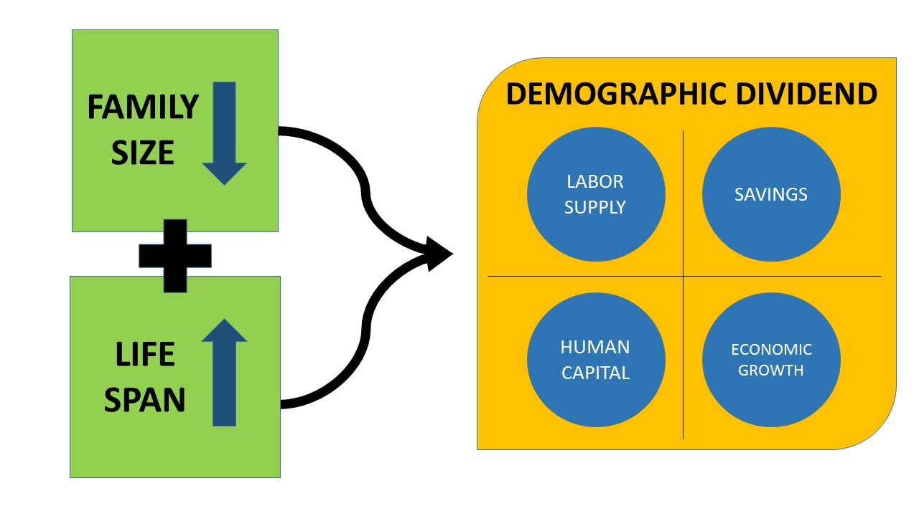

Watch | Read | Listen
https://www.youtube.com/watch?v=Z5Blp58zCSo | www.imf.org/external/pubs/ft/fandd/2006/09/basics.htm | https://www.bbc.co.uk/sounds/play/p04cgdps - up to 11:45
Place where this is happening? | Brief summary
Discuss:
- Is there an optimum population size?
- What processes could be used to achieve this?

Part 2 - Geo-engineering for Global Climate Change

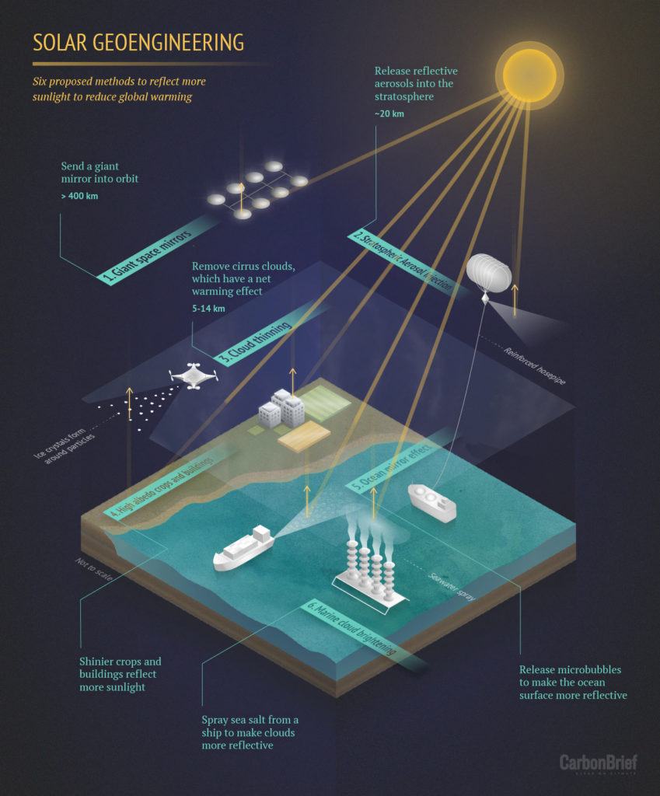

Watch | Read | Listen
www.youtube.com/watch?v=OGdz5gYqm-o | www.carbonbrief.org/explainer-six-ideas-to-limit-global-warming-with-solar-geoengineering | https://www.bbc.co.uk/sounds/play/b03ktz14
Place where this is happening? | Brief summary
Discuss:
- Are humans responsible for Climate Change?
- To what extent can humans reverse the effects of GCC?
- Who should pay for these new geo-engineering strategies?

Part 3 - The Water-Food-Energy Nexus

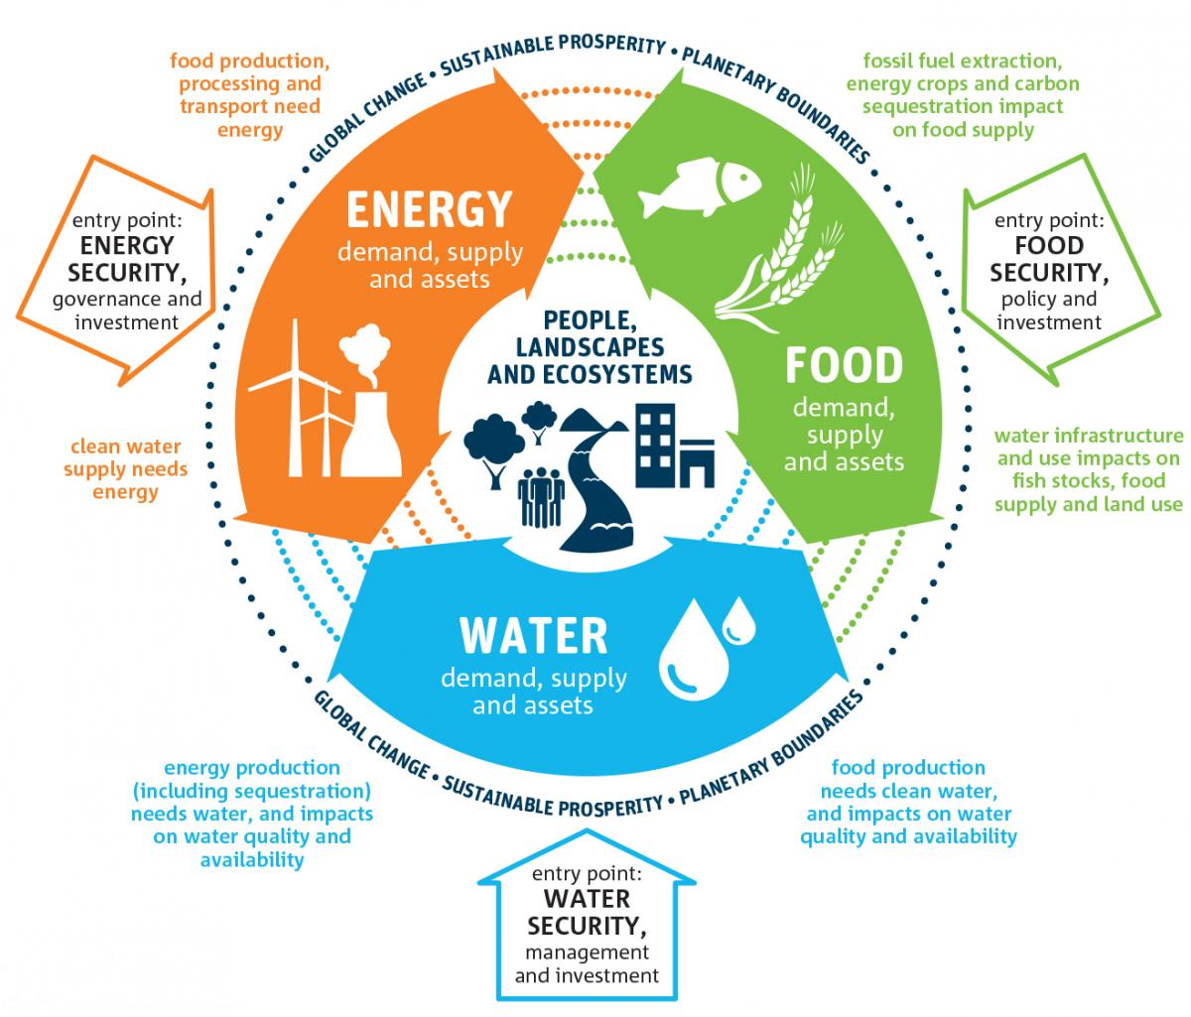

Watch | Read | Listen
www.youtube.com/watch?v=CKW_ux2Xo_w | www.unwater.org/water-facts/water-food-and-energy/ | https://www.bbc.co.uk/sounds/play/p02kbhq0 (first 14 mins)
Place where this is happening? | Brief summary
Discuss:
- To what extent are HICs mostly responsible for the negative effects experienced by those in LICs?
- How can we reverse the effects of water-food-energy insecurities?

Part 4 - Linear and Circular Economy

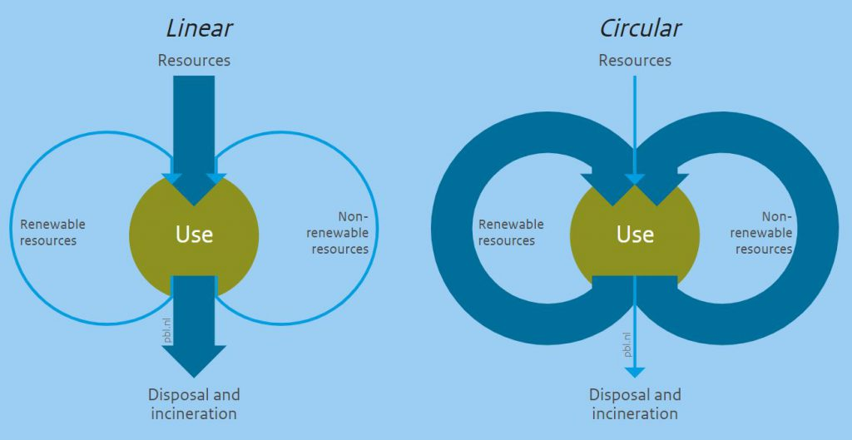

Watch | Read | Listen
www.youtube.com/watch?v=zCRKvDyyHmI | kenniskaarten.hetgroenebrein.nl/en/knowledge-map-circular-economy/how-is-a-circular-economy-different-from-a-linear-economy/ | https://www.bbc.co.uk/programmes/b05r40r7
Place where this is happening? | Brief summary
Discuss:
- Should the circular economy be enforced globally?
- Is it possible to ever prevent the linear economy from existing?

Part 5 - UN Sustainable Development Goals

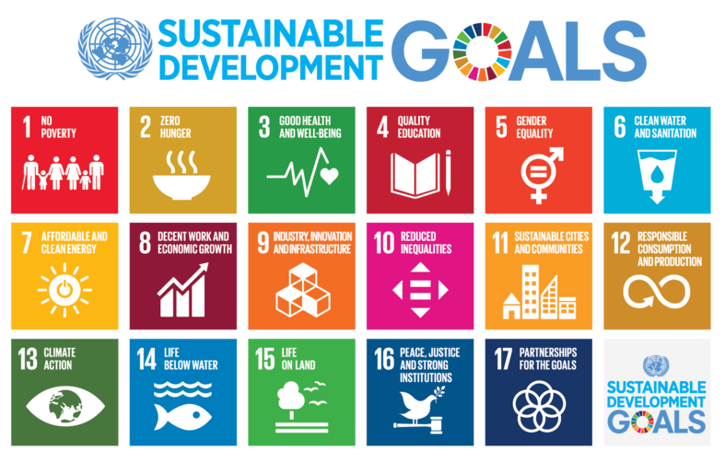

Watch | Read | Listen
www.youtube.com/watch?v=7V8oFI4GYMY | https://www.un.org/sustainabledevelopment/development-agenda/ | https://www.undispatch.com/podcast-how-much-progress-are-we-making-towards-the-sustainable-development-goals/
Place where this is happening? | Brief summary
Discuss:
- How successful do you think the UN will be in achieving the 17 SDGs?
- Is it possible to hold countries accountable for not abiding by these goals?
- To what extent can the SDGs actually ‘transform our world’?
- What evidence of SDG activity can you see in your school environment? (investigation)

Part 6 - Global superpowers

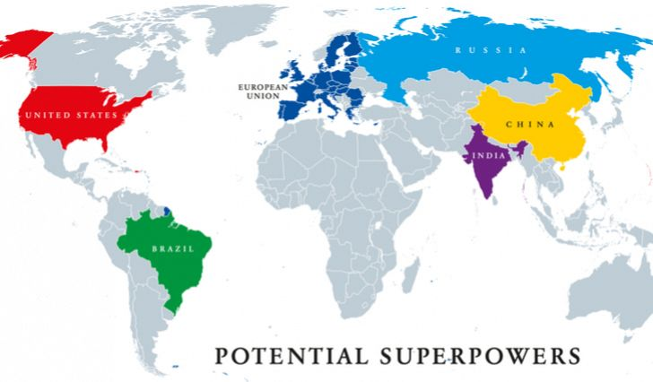

Watch | Read | Listen
www.youtube.com/watch?v=mvt_4DqPjvc | http://www.bbc.com/travel/story/20200322-five-superpowers-ruling-the-world-in-2050 | https://www.bbc.co.uk/sounds/play/b086tfbh
Place where this is happening? | Brief summary
Discuss:
- Why do superpowers exist?
- To what extent are superpowers morally obliged to help other countries to develop?
- Will China be the most dominant economy in the world by 2050?

Part 7 - Cultural imperialism and hybridity

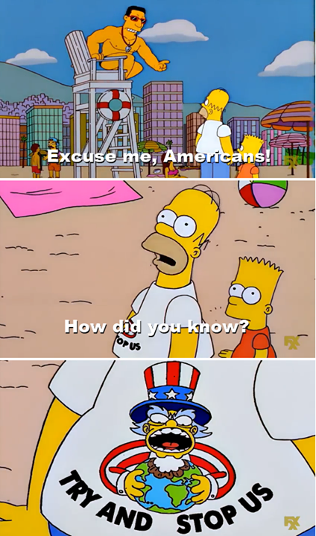

Watch | Read | Listen
www.youtube.com/watch?v=F2R6C5Iiaz0 | http://share.nanjing-school.com/dpgeography/2014/03/20/cultural-imperialism/ | https://soundcloud.com/alserkalavenue/understanding-cultural-hybridity
Place where this is happening? | Brief summary
Discuss:
- How westernised has the world become?
- Is it possible to reject globalisation and its adaptation of local cultures (glocalisation)?
- Is hybridity a bad thing?
Part 8 - Disruptive technological innovations

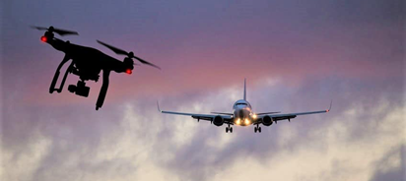
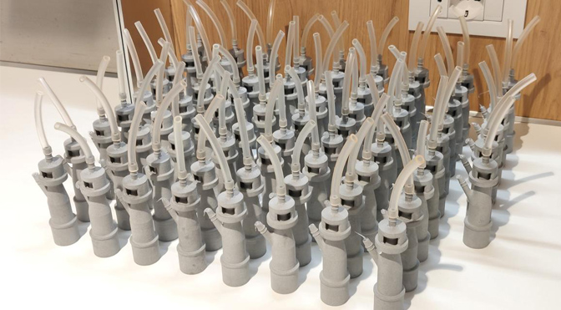

Watch | Read | Listen
www.youtube.com/watch?v=tefu0dmt9l0 | https://www.investopedia.com/terms/d/disruptive-innovation.asp | https://www.bbc.co.uk/programmes/p04fdtf9 & https://www.bbc.co.uk/programmes/b0b7f15s
Place where this is happening? | Brief summary
Discuss:
- How many examples of disruptive innovation can you name?
- To what extent are disruptive technological innovations a positive influence for humankind?

Geophysical hazards key terms:

You have all studied hazards as part of your IGCSE course. Here are some key terms that

Key term | Definition
Asthenosphere
Lithosphere
Subduction
Primary waves (earthquakes)
Secondary waves (earthquakes)
Spatial Distribution
GPS
Cinder volcano
Low viscosity
High viscosity

