IB DP Geography – Peak Oil Infographic Analysis
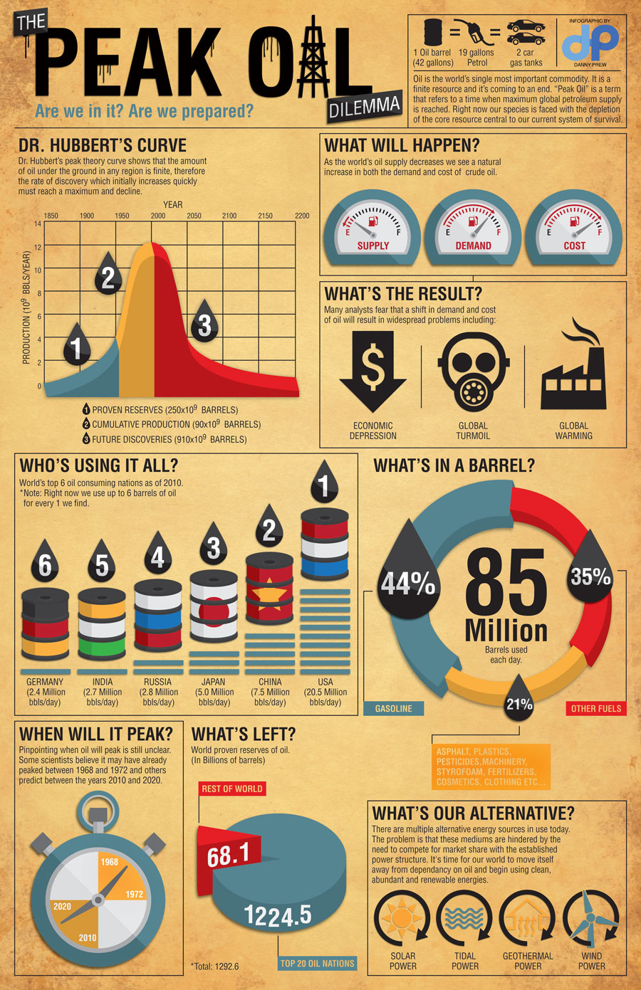

Refer to the infographic overleaf.
The infographic shows the issues related to Peak Oil.
- Using the Dr. Hubert’s Curve graph, estimate the year in which Peak Oil was reached. (1)
………………………………………………………………………………………………………………………………………………………………………………………………………………………………………………………………………………………………………………

- Determine the total percentage of oil contained in a barrel that goes into making fuels. (1)
………………………………………………………………………………………………………………………………………………………………………………………………………………………………………………………………………………………………………………

- Using evidence from the infographic only, explain one possible challenge faced by countries in dealing with ‘Peak Oil’ (2)
………………………………………………………………………………………………………………………………………………………………………………………………………………………………………………………………………………………………………………………………………………………………………………………………………………………………………………………………………

- What are the issues with this infographic and how could it be improved. (6)
………………………………………………………………………………………………………………………………………………………………………………………………………………………………………………………………………………………………………………………………………………………………………………………………………………………………………………………………………
………………………………………………………………………………………………………………………………………………………………………………………………………………………………………………………………………………………………………………………………………………………………………………………………………………………………………………………………………
………………………………………………………………………………………………………………………………………………………………………………………………………………………………………………………………………………………………………………………………………………………………………………………………………………………………………………………………………
………………………………………………………………………………………………………………………………………………………………………………………………………………………………………………………………………………………………………………………………………………………………………………………………………………………………………………………………………

