IB DP Geography – Eco City in the desert - Masdar
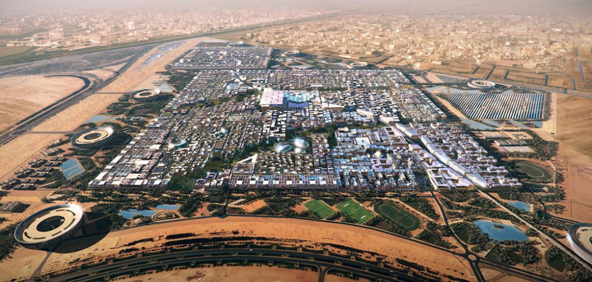
Watch the first video on geographypods and make brief notes on why Abu Dhabi has such a high ecological footprint (note link to Climate Change work).

Place Detail (where and why there) | Power (stakeholders)
 | DEWA
Process (how does it aim to be an eco-city?) | Possibility (evaluation)

