IB Geography – South Africa World Cup 2020 – Note Taking
“Football can make a small country big”
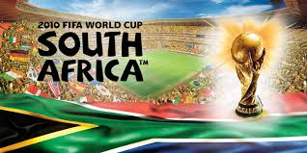
How often is the Football World Cup held?
What does FIFA represent?

Why was the 2010 tournament in South Africa meant to be so special?

Perspectives - Throughout the film, take notes in the pros and cons columns below. The headings of each column are quotes from participants in the film who are for or against the event.
A superb moment” for South Africa that “is going to do a world of good and be well worth the price”. | A “misappropriation of resources” that could be used for schools, hospitals, and eliminating poverty.

FIFA structure, corruption & profits

Impact on South Africa football and finances.

Outline the tangible* and intangible* benefits that South Africa expected to gain from the Olympics. [6]

Explain why South Africa attracted criticism from some people at the time of the Games. [4]
*What are tangible and intangible benefits?

Sporting events have lasting impacts and can be thought of as ‘tangible’ and ‘intangible’. Tangible legacy refers to specific ‘touchable’ things such as improved transport infrastructure, urban regeneration and new parks. Intangible legacy refers to more abstract things such as changes in attitudes to sport, national pride and greater awareness of environmental issues.

