IB Geography – Factors Affecting Participation in Sports & Tourism

Major Football Ground | Major Golf Course | Major Baseball Stadium
Major Basketball Arena | Major Cricket Arena | Major Tennis Venue
Major Rugby Stadium | Major Boxing Ring | Major F1 Circuit

Plot the locations of examples of well-known facilities (above) on to the map.

This site might help you: http://www.sportmapworld.com/

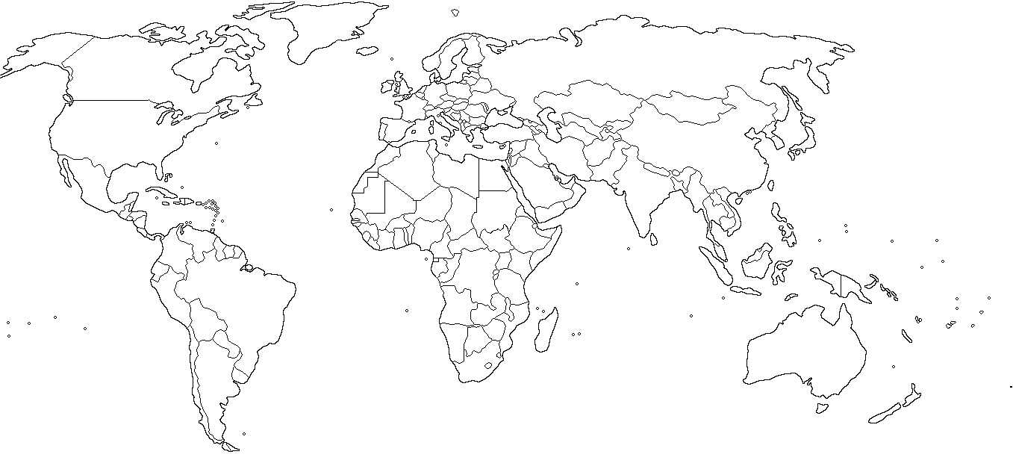

On the map on the previous page, also locate the following human factors that influenced tourism & sport and add a short explanation.
