​IB Geography - Inclusion in Sport via Changing Gender Roles
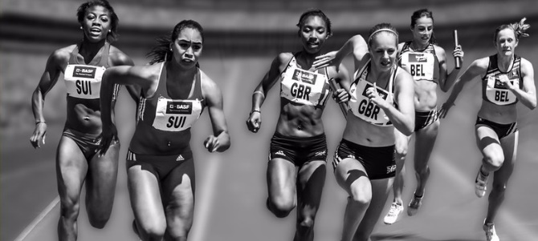
Case Study 1 – Trans Gender Sport Debate.

Outline the changing gender role and the sport | Outline how this is inclusion is being attained.
Describe any barriers that have had to be overcome | Evaluate the strengths and weaknesses of the policy.

Case Study 2

Outline the changing gender role and the sport(s) | Outline how this is inclusion is being attained.
Describe any barriers that have had to be overcome | Evaluate the strengths and weaknesses of the policy.
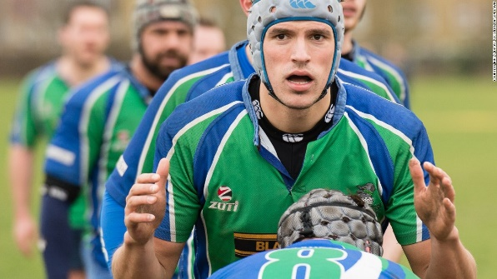
Case Study 3 – Gay Rugby Team, London.

Outline the changing gender role and the sport | Outline how this is inclusion is being attained.
Describe any barriers that have had to be overcome | Evaluate the strengths and weaknesses of the policy.
Case Study 4 - Development of W-Series Racing

Outline the changing gender role and the sport(s) | Outline how this is inclusion is being attained.
Describe any barriers that have had to be overcome | Evaluate the strengths and weaknesses of the policy.

