IBDP Geography - Case Study of One National Sports League

Objective: Discover the factors affecting the geography of a national sports league, including the location and hierarchy of its teams and the distribution of supporters

Case Study – Ligue 1 Football, France.

Ligue 1 or Le Championnat is the premier division in France in which 20 different clubs compete. These 20 clubs are spread over mainland France and play 38 league games per year. The league has gained international recognition in recent months with the PSG securing the services of Lionel Messi from FC Barcelona.
Over to you:

http://en.wikipedia.org/wiki/Ligue_1

Task 1 - Locating the Teams

Use the web link underneath. Spend a little time studying the map to show the locations of the current French Ligue 1 teams. Comment on the spread of teams in France. Don’t forget to mention locations linking with urban areas, accessibility, relief and degree of isolation.

https://sportleaguemaps.com/soccer/europe/western/ligue-1/

Task 2 – Hierarchy & Success of Ligue 1 Teams

Go to the following web links and make a note of the Champions, runner up and third placed finisher for the last three seasons.
http://en.wikipedia.org/wiki/List_of_French_football_champions#Championships_by_club

 | 1st Place & Winners | 2nd Place | 3rd Place
Last season
Previous season
Previous season

Compare the results above to this table that shows overall winners of the Ligue 1 in the ‘professional era’ – ‘professional’ means since the players have been paid to play, and consider playing football as their one and only job.

Enter the names and date below.

Team | N.o time won the league | N.o times runners up

Task 3 – Attendances and popularity

https://www.transfermarkt.fr/ligue-1/besucherzahlen/wettbewerb/FR1/plus

This is the average number of spectators so far this season in Ligue 1 for each club.

Complete two pieces of writing about the attendances & popularity of the top two clubs

Include:
- Name and location
- Population of town/city hosting the club (data here)
- What is the link between attendance and the success of the club?
Look at:
- Seasons in Ligue 1
- League titles Won
- First season of current spell in top division. (Target 100 words for each)

Top watched club **Enter name**

Second most watched club **Enter name**

Task 4 – Location & Residence of supporters (sphere of influence)

You can presume that the vast number of people that turn up on match day will live in the area surrounding the stadium, whether that be in Marseille or Toulouse.

Why is your chosen Ligue 1 team located where it is within each settlement? See the Toulouse FC (currently Ligue 2) example on the following page.

You will need to use Google Maps/Earth to locate one of the stadiums (Paris Saint Germain or Olympique Marseille are best). Their addresses can be found on the https://www.ligue1.fr/clubs/liste under the club profile. You should take a screen shot of the Google map and cut and paste into the space provided. Annotate each image to show the relationship between team location and residence of supporters.

Turn over for example

Example – Toulouse FC (Ligue 2)
Large residential areas of social housing and apartments within walking distance

Outer ring road. Direct links to Paris, Bordeaux and Montpellier

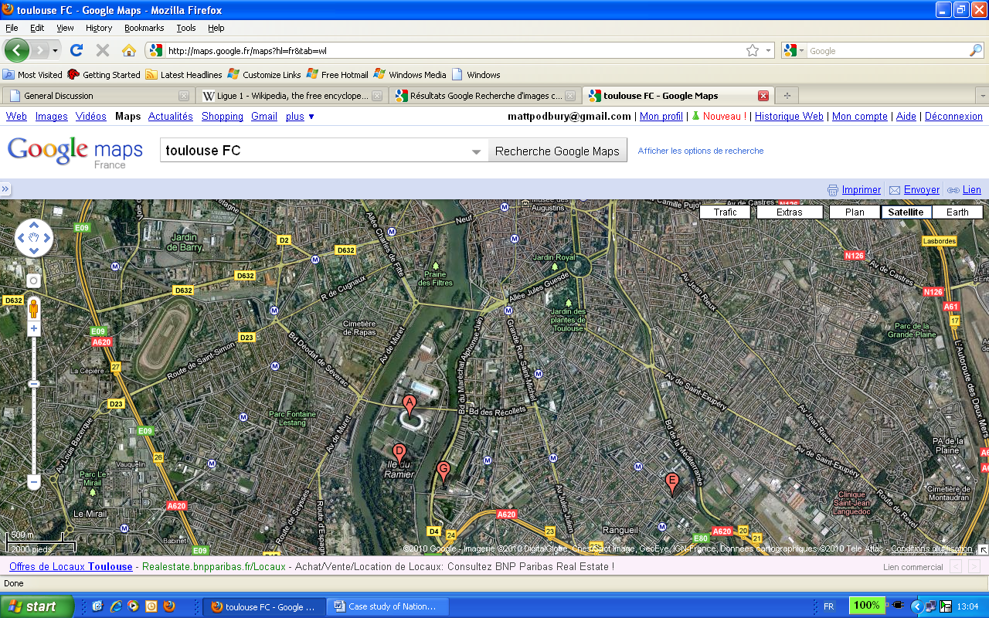

Proximity to major leisure development, swimming pool. Leisure experience.

Stadium location
Public transport links such as the Toulouse metro and bus services.

Inner ring road for ease of transportation to and from the game to those who live outside the city centre

Commentary
Toulouse FC is located approximately 1.5km southwest of the historical core of Toulouse city centre. It is located on an island on the banks of the Garonne river. Toulouse city is located in southwestern France and is a large conurbation of more than 1.5 million people located between the Massif Central and the Pyrenees. The nearest big settlements are Bordeaux: 200 KM north west and Montpellier, 300KM east. The city is served by an international airport and is on the main train line between Paris (north) and Barcelona (south east). The city has a famous sports history with Rugby and football is very much its second sport. The stadium is located very close to the rocade and close to main bus routes metro links. Most fans who live in the city can access the stadium by foot, bus, metro, or drive by car. The football club serves the surrounding settlements as far as Colomiers (Northwest), Muret (south) and Grenade (north). The most famous and successful club in the south of France is Olympic Marseille (400km to the east). Their fan base stretches internationally and many people living in the Toulouse area support this club. Toulouse FC is a relatively small club with an average match attendance of 20,000 people and very limited success. For this reason, they are barely known outside of France and as such cannot attract big name players. Due to this lack of success, they have a small but committed fan base who are from the Toulouse and surrounding Occitane area. There is a clear relationship between the location of the team and the location of its supporters. Only future successes may widen the appeal of Toulouse FC and its national & international fan base.

Your Example – Paris Saint Germain or Olympique Marseille (Ligue 1)

Task 5 – Supporters away from the residence of the club.
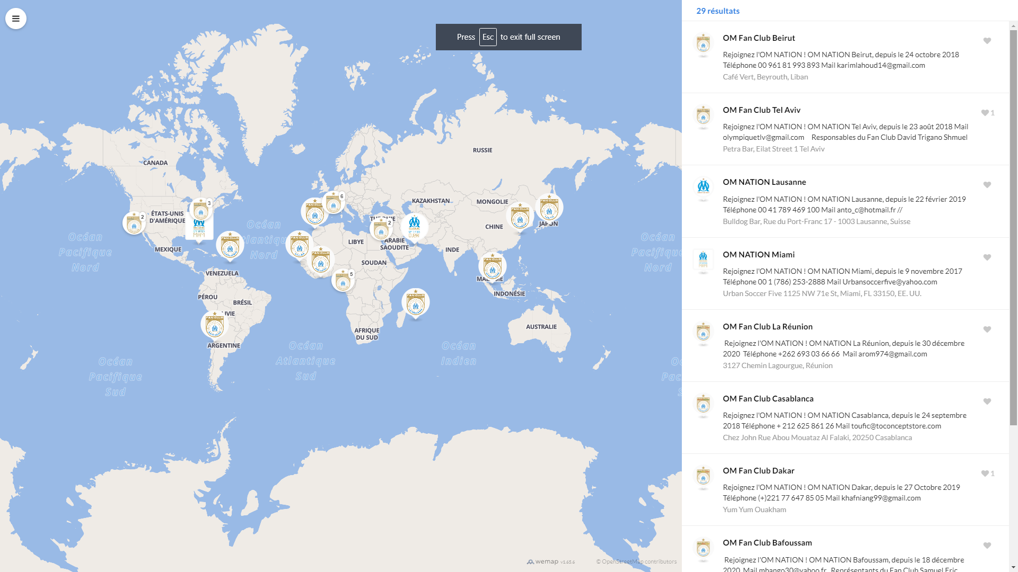

Source of map above & for larger version: https://www.om.fr/en/gamme/19400/19400-om-nation-fan-clubs

The map above shows the official L’OM supporters clubs globally. Complete a short piece of work on why L’OM appeal to fans globally. Think about migration, player origin, success, social media, television rights and Francophonie countries.

Task 6 – Exam Question

Explain the relationship between the location of one or more teams and the residence of their supporters. (10)

Don’t forget to consult the IB mark scheme and planning framework when planning to answer this question.

