IB Geography – Cultural Shift & The Growth of E-Sports
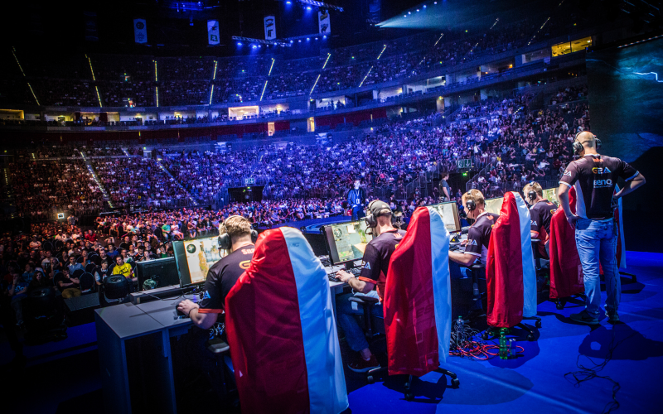
Video 1 - Define e-sports and refer to growth in viewing figures.

Video 2 to 2:30 - Who are the Houston Outlaws, how and where to they play and how do they prepare?

Video 2 - 2.30 onward. What is Overwatch and how does it work?

How does the consumer interact with the competition?

How do the players live from day to day?

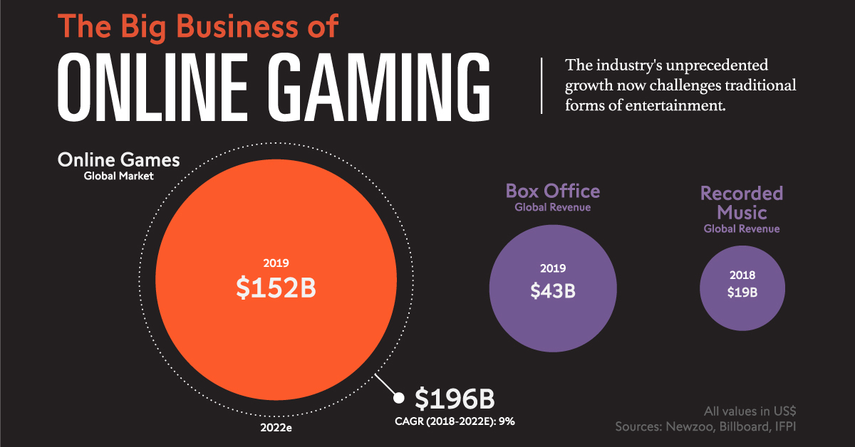

Describe the popularity of online gaming compared to more traditional leisure pursuits as shown in the graphic above.

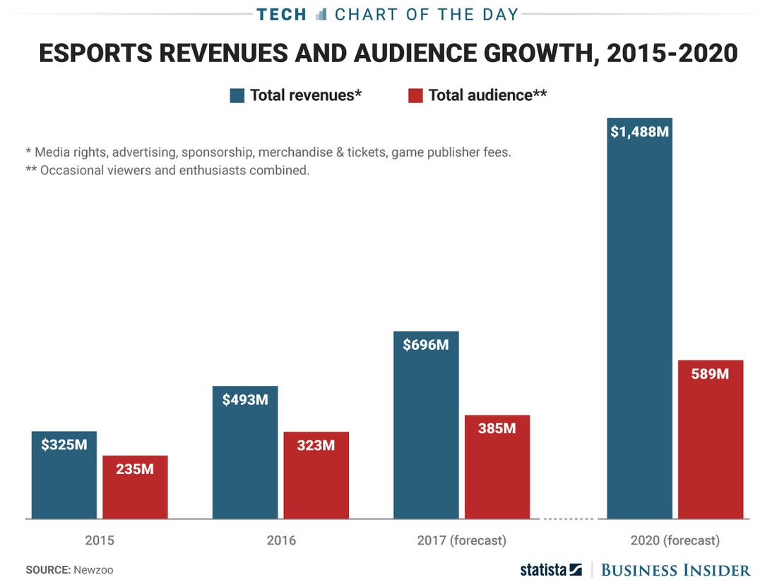

Describe the trends both esports revenue and audience numbers in the chart above.

Click on this link to access a January 2021 article about Johan "N0tail" Sundstein. Make notes on the content of the video in the space below.

To what extent has cultural influence driven the growth of Esports?

