IB Geography - ​Costs & Benefits of Tourism as a National Development Strategy – Part 1
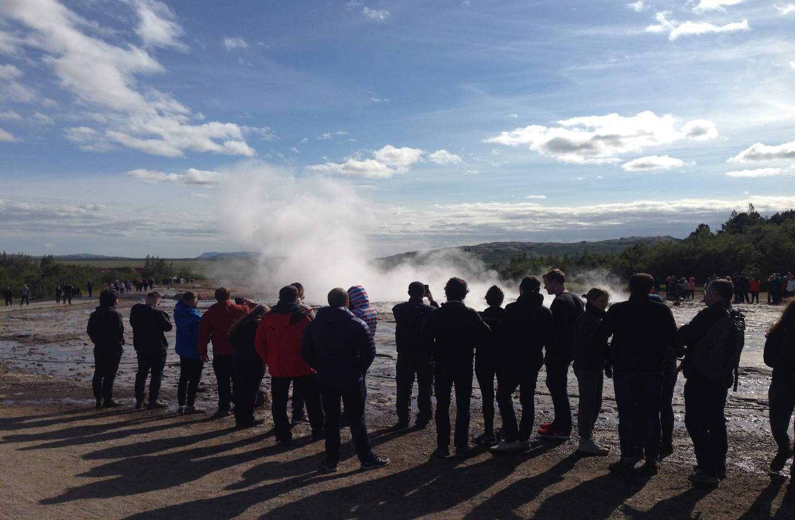
Task 1 – Complete the word fill exercise on the Butler Model and then paste the completed text into the space below.

Paste here:

Task 2 - Iceland & The Butler Model & Irridex

Annotate your Butler Model & Irridex with relevant information from the excellent article from Paul Berry on ibgeographypods

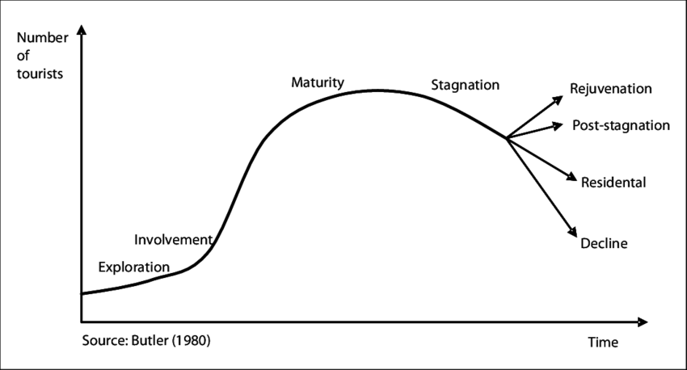

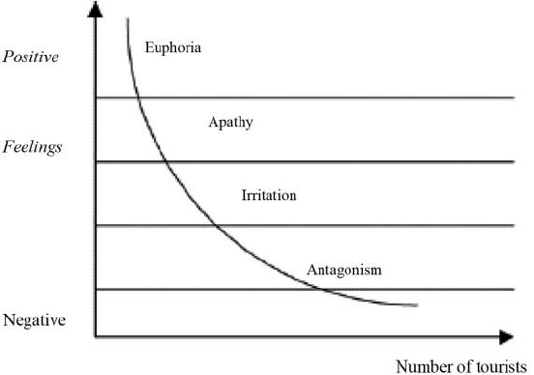

Task 3 - Discuss - To what extent could creating a honeypot around the Golden Circle help Iceland to manage tourism numbers and the environmental impacts of tourism?

