|  |
| --- |
| **IB Geography – ​Tourism as a National Development Strategy – The Maldives** |

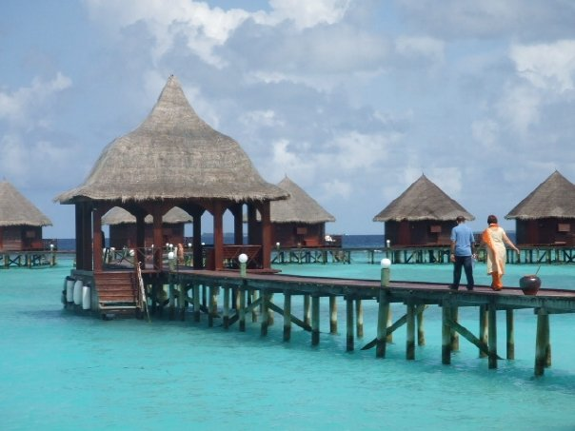

Fig 1. Maldives. M Podbury (2007)

|  |
| --- |
| **Task 1** – Complete the [word fill exercise on the Butler Model](https://www.coolgeography.co.uk/GCSE/AQA/Tourism/Life%20cycle%20model/Butler_model_cloze.htm) and then paste the correct and completed text into the space below. |

Paste here:

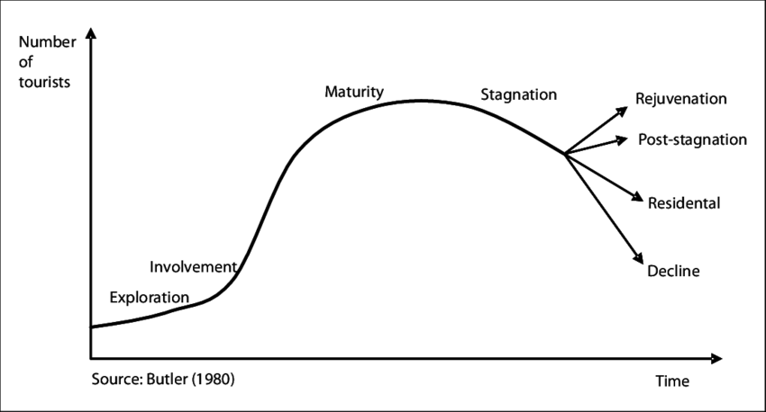

Figu 2. Butler Model.

|  |
| --- |
| **Task 2** – [Read this article](https://www.travelandleisure.com/trip-ideas/island-vacations/maldives-history) and write a 200-word summary of the history of tourism in the Maldives. Annotate key dates and features onto the Butler Model above. |
|  |

|  |
| --- |
| **Task 3** – **Costs** - [**Read this 2021**](https://www.cnbc.com/2021/03/02/tourism-dependent-maldives-steps-up-economic-diversification-effort.html) article from CNBC. Outline how the global COVID-19 pandemic has impacted on tourism in the Maldives. Make sure you use data in your writing. |
|  |

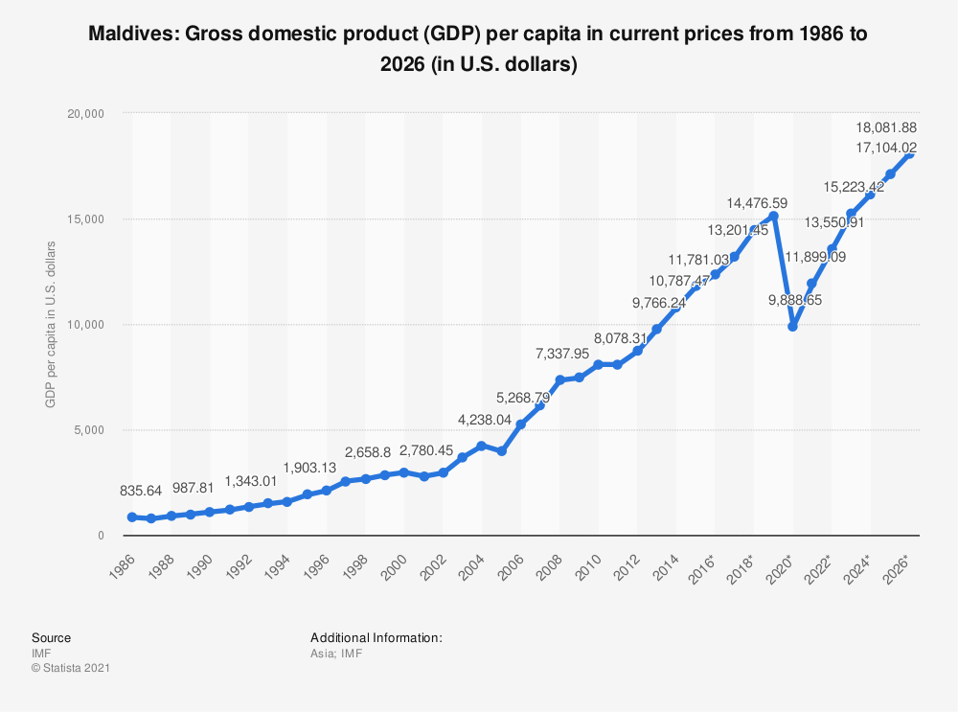

Fig 3. GDP growth per capita in The Maldives (Source IMF)

|  |
| --- |
| **Task 4** – **Benefits** - Describe the growth in GDP per capita in the Maldives in the 40-year period. |
|  |

[Link to original data source](https://www.google.co.uk/search?hl&q=maldives+life+expectancy)

|  |
| --- |
| **Task 5**  – **Benefits** - Describe life expectancy trend in The Maldives from 1960 to 2019. |
|  |

|  |
| --- |
| **Task 6** – **Costs** – [Read this article](https://www.breakingtravelnews.com/news/article/maldives-unveils-2020-tourism-strategy/) and watch the YouTube video on waste disposal in The Maldives. Outline the issues that this brings to a small island nation, particularly related to tourism. |
|  |

|  |
| --- |
| **Task 7** – **Benefits** - [Read this article](https://www.breakingtravelnews.com/news/article/maldives-unveils-2020-tourism-strategy/) and summarise how The Maldives are aiming to use niche markets to boost their tourism strategy in coming years. You will need to find out what ‘MICE’ means. |
|  |

|  |
| --- |
| Evaluate the costs and benefits of tourism as a national development strategy. [10] |
|  |