IB Geography – ​Tourism as a National Development Strategy – The Maldives
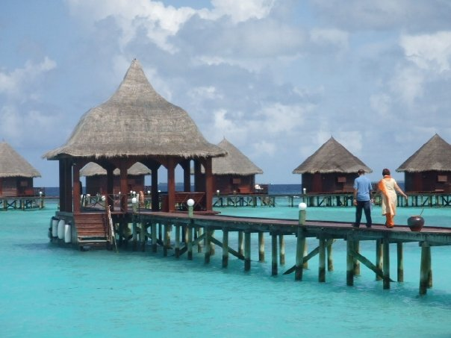
Fig 1. Maldives. M Podbury (2007)
Task 1 – Complete the word fill exercise on the Butler Model and then paste the correct and completed text into the space below.

Paste here:

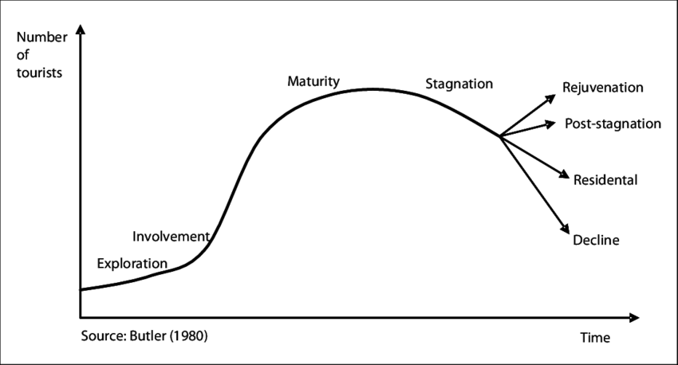

Figu 2. Butler Model.

Task 2 – Read this article and write a 200-word summary of the history of tourism in the Maldives. Annotate key dates and features onto the Butler Model above.

Task 3 – Costs - Read this 2021 article from CNBC. Outline how the global COVID-19 pandemic has impacted on tourism in the Maldives. Make sure you use data in your writing.

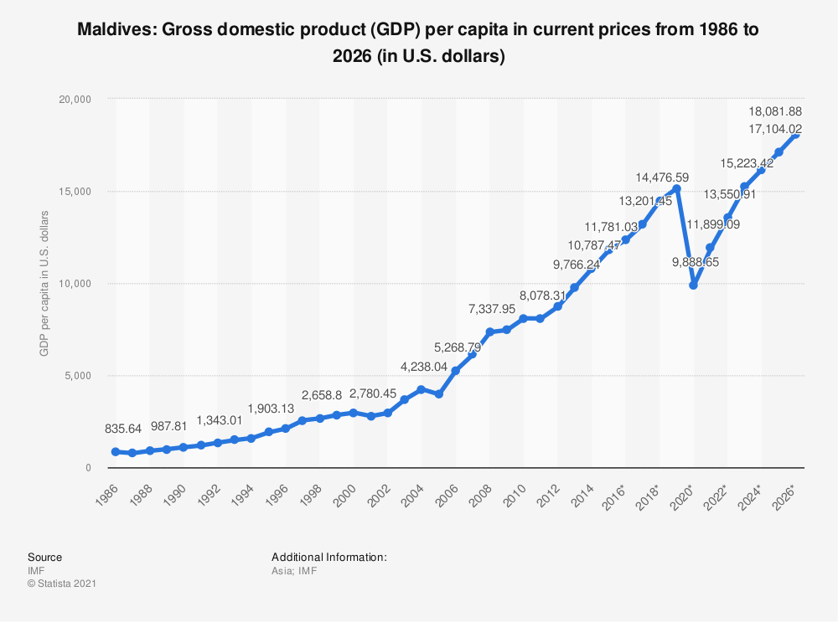
Fig 3. GDP growth per capita in The Maldives (Source IMF)
Task 4 – Benefits - Describe the growth in GDP per capita in the Maldives in the 40-year period.

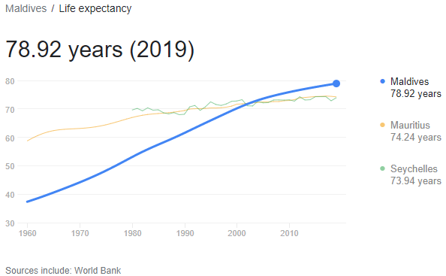
Link to original data source

Task 5 – Benefits - Describe life expectancy trend in The Maldives from 1960 to 2019.

Task 6 – Costs – Read this article and watch the YouTube video on waste disposal in The Maldives. Outline the issues that this brings to a small island nation, particularly related to tourism.

Task 7 – Benefits - Read this article and summarise how The Maldives are aiming to use niche markets to boost their tourism strategy in coming years. You will need to find out what ‘MICE’ means.

Evaluate the costs and benefits of tourism as a national development strategy. [10]

