IB Geography – The Growth of Ecotourism
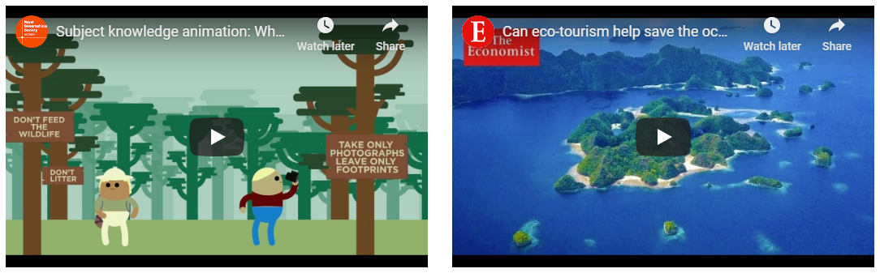
Video 1 – What is ecotourism?

Video 1 - What are the three key principles to ecotourism? Add a brief explanation after each.
1

2

3

Video 2 - Can Tourism Help to Save the Ocean?
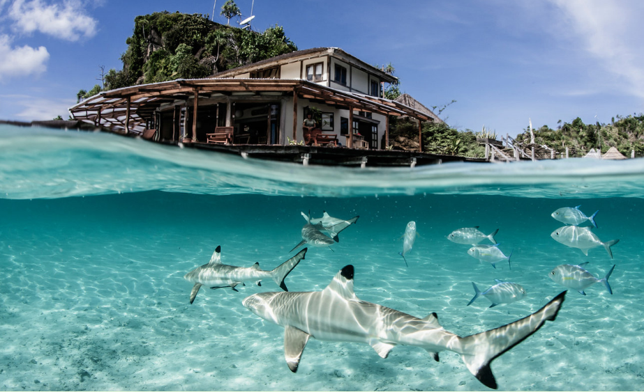
Watch the second video embedded on ibgeographypods. Take notes on the marine conservation project in Indonesia and how it links to ecotourism. Use the 4P’s approach.

Place | Process
Power | Possibility

