IB DP Geography – A 9-minute History of the Cold War 1947-1991 – Note Taking Frame
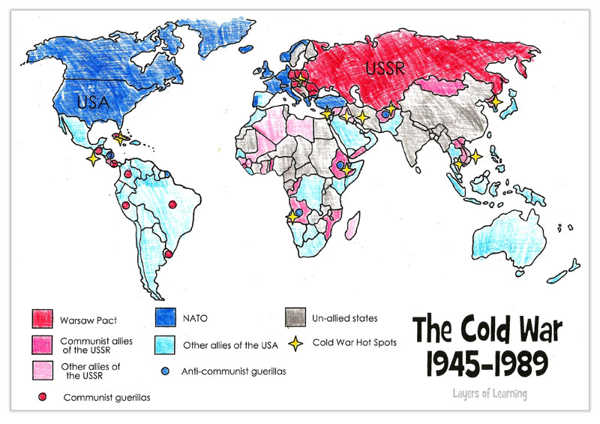
1 - Source https://layers-of-learning.com/cold-war-map-world/

