IB Geography - The Categorization of Sporting Activities
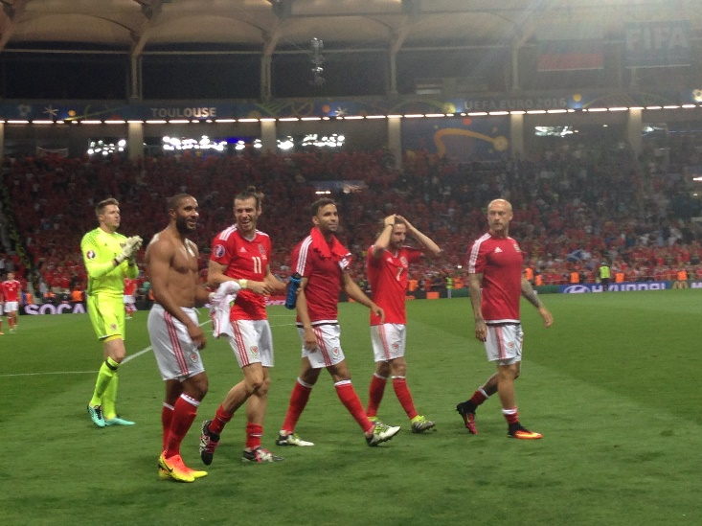
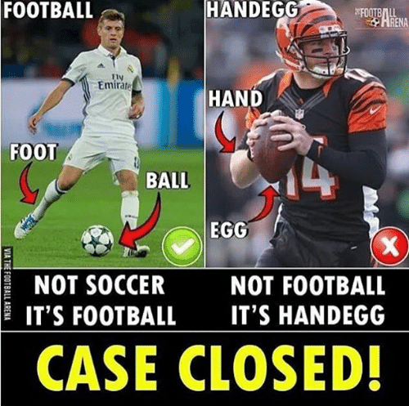
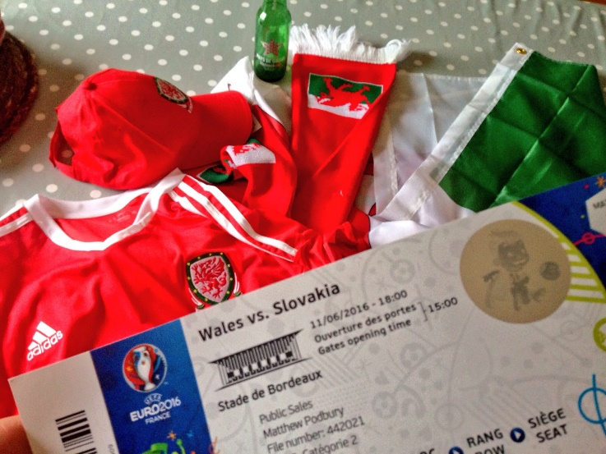

Using the table below, enter as many sports as you can think of into each of the five categories.

Physical | Mind | Motorised | Coordination | Animal supported

Now add at least three sports in the following categories - low, mid and high cost. This can be to watch (spectate) or to participate in.
Low Cost | Middle Range Cost | High Cost
1  2  3 | 1  2  3 | 1  2  3

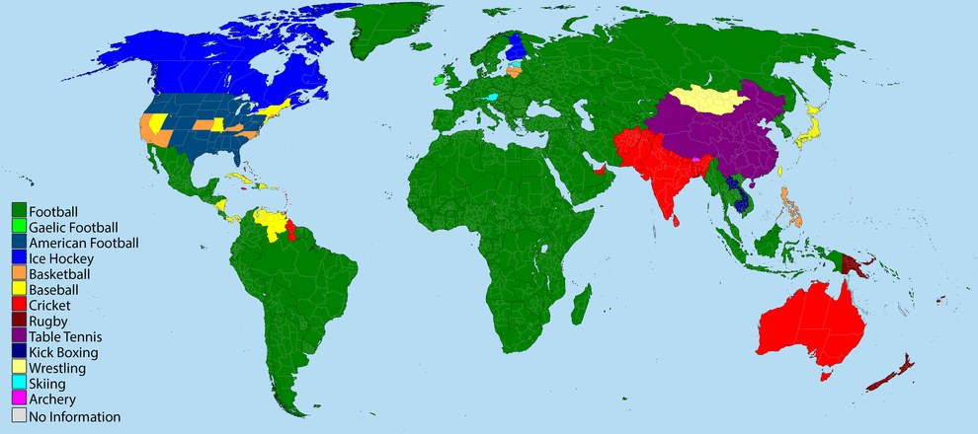
Source: Reddit
Describe how socio-economic factors may influence how popular a sport is.

Describe how physical factors may influence how popular a sport is.

