IBDP Geography – Tourism & the Costs & Benefits of TNC Involvement for Different Stakeholders
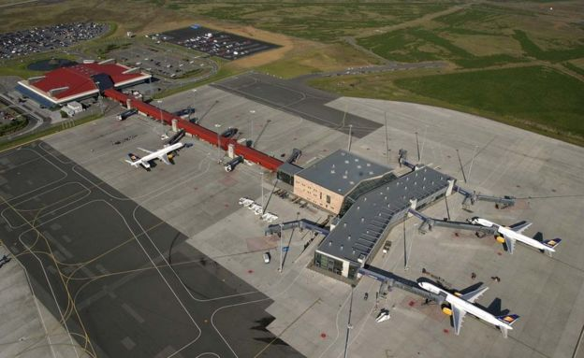
The focus in this section will be on Iceland's Keflavik Airport and the growth of tourism in Iceland.

Quick data check. Use the airport website here to fill in the key data details below.
Most recent estimation of passenger numbers per year
Number of airline companies operating to the airport

Using the link on ibgeographypods and the first section of the news article, complete the stakeholder analysis box below.
Stakeholder | Position/Job etc. | Views
Steinthor Jonsson
Bjorn Jonasson
John Strickland
Now watch this video from Discover The World Education and complete the same activity below.

The Geography Teacher | Head of Geography
The Geography students | On a school trip

What is the link between budget airlines such as EasyJet (who fly in to Iceland) and the rise in school trips to Iceland in the last 10 years?

