IBDP Geography - The Role of TNCs in Expanding International Tourism Destinations
Ryanair & EasyJet

Watch the embedded video on ibgeographypods and complete this note taking sheet.
How Ryanair & EasyJet have expanded international tourist destinations for travel within Europe & North Africa. |  | 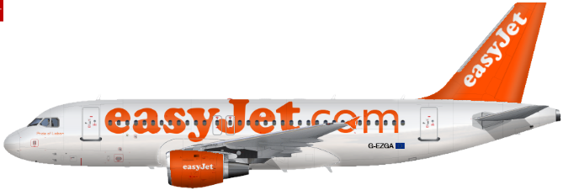
Founder & further details e.g. nationality & wealth.
Where did the concept of low-cost airlines come from?
Brief history of the airline

This comes in different segments of the video so you will need to revisit this section several times to add information.
Explain how the rise of stag night tourism in places like Riga has impacted on the countries.
Which brand of plane do each fly and why?
The use of ‘smaller out of the way airports’

**Ryanair only**
How does each budget airline make money?

How did EasyJet react to the launch of Go (British Airways) budget airlines.

Outline the impact of budget air travel on the area around Limoges Airport, France
Explain how Ryanair publicize their services & spend so little on advertising.

What are the possible dangers to the budget airline model?

Which airline offers the best service (in your opinion and after having watched the documentary and possibly travelled on each carrier)?

