IB Geography - Human and physical factors & rural tourism hotspots – Machu Picchu A3 Sheet
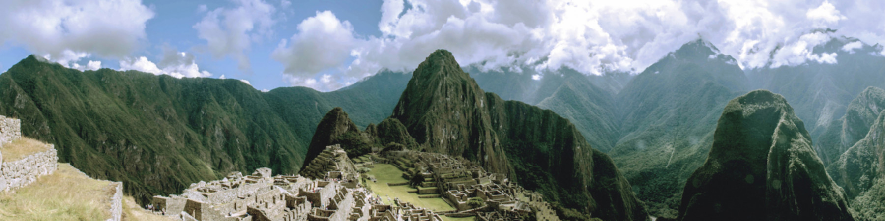
Physical Factor | Evidence from resources | Human Factor | Evidence from resources

Place | Process | Power | Possibility

