IB DP Geography – Consequences Of Unsustainable Touristic Growth – Urban Hotspot - Venice
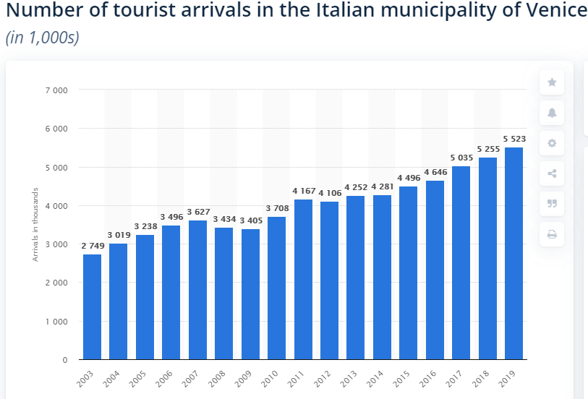
Task 1 – Outline the issues surrounding the carrying capacity of Venice.
Task 2 – Explain how the structure of the city impacts on carrying capacity.
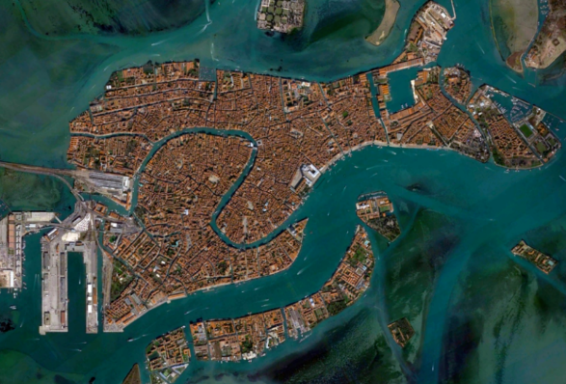

Task 4 – Outline the main features of #EnjoyRespectVenezia – Use this link. Continue on the next page.

Task 3 – Study the graph above right and describe the tourism trends shown making reference to total increase between 2003 and 2019. Suggest the likely origin of many of these tourists and link that to what you learnt about the rise of the middle classes earlier in the course.

Task 4 – Continued….

Exam Practice: Referring to one example, discuss the strategies that may be used to manage the carrying capacity of a popular tourist attraction in an urban area (10)

