IB Geography – Reasons For Growth in Leisure Time
Complete the table below by analysing the images (larger images available on ibgeographypods) and deciding on the factor and how it has influenced the amount of leisure time that people experience.

Image | Factor | Description of influence on leisure time
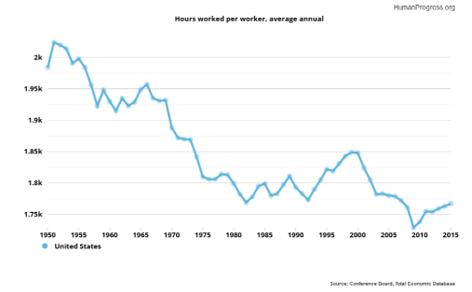

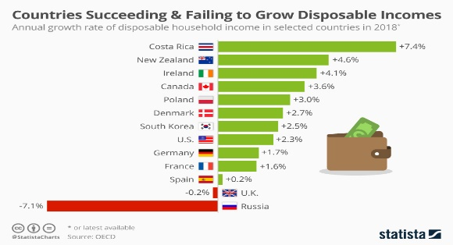

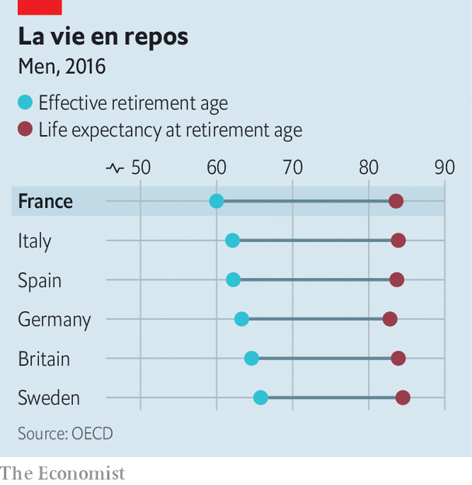

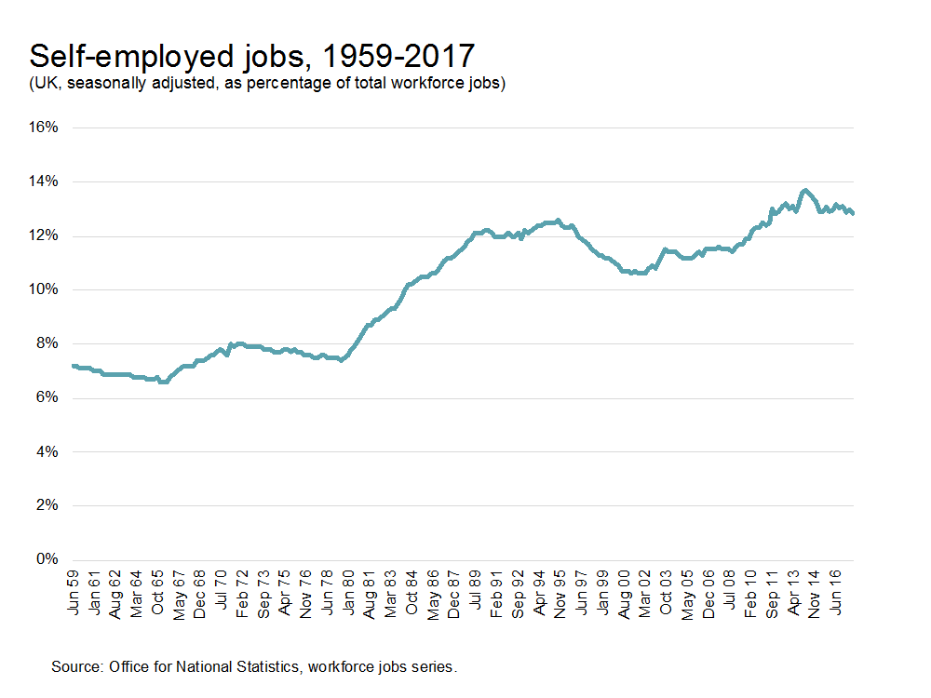

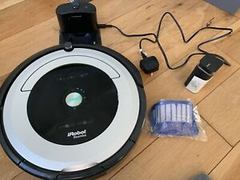

Using the two images below, explain how and why gender disparity can occur in terms of total leisure time.
