IBDP Geography – Niche Tourism in Iceland
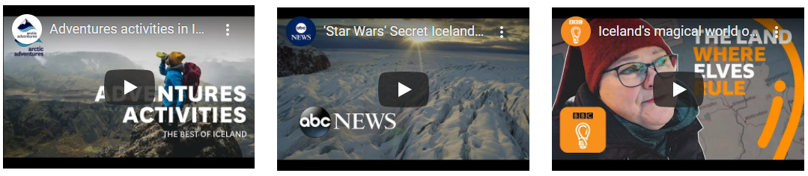

Define ‘niche tourism’.

Part 1 – Adventure Tourism in Iceland
Image in Iceland | Definition | Example activities
Identify the influencing geographical factors that allow for this type of tourism to take place and explain how this influences demand.

Part 2 – Movie Location Tourism in Iceland
Image in Iceland | Definition | Example Films / videos
Identify the influencing geographical factors that allow for this type of tourism to take place and explain how this influences demand.

Part 3 – Heritage Tourism in Iceland
Image in Iceland | Definition | Examples
Identify the influencing geographical factors that allow for this type of tourism to take place and explain how this influences demand.

Outline the issues caused by Game of Thrones and the Justin Bieber music video on the Fjaðrárgljúfur canyon in Iceland.

