IB DP Geography – Introducing the KOF Index

The KOF Index of Globalization is an index of the degree of globalization of 122 countries. It was conceived by Axel Dreher at the Konjunkturforschungsstelle of ETH Zurich, in Switzerland. It was first published in 2002, and covered the period from 1970 until that year. A new version of it was published in 2017 (Wikipedia). It is measured on a scale from 0.00 – 100.00
The KOF Globalization Index measures the economic, social and political dimensions of globalization. It does not cover environmental globalization. Globalization in the economic, social and political fields has been on the rise since the 1970s, receiving a particular boost after the end of the Cold War.
The three components
. Economic globalization is measured by the actual flows of trade, foreign direct investment and portfolio investment, as well as the restrictions applying to these flows.
. Social globalization is expressed as the spread of ideas, information, images and people. It is estimated by personal contact (international telephone traffic, transfers, tourism, foreign population, and international letters), information flows (Internet users, television ownership, trade in newspapers), and cultural proximity (number of McDonald’s restaurants, number of Ikea shops and trade in books).
. Political globalization is characterized by the degree of political cooperation. It is measured by the number of embassies, membership of international organizations, participation in UN Security Council missions, and number of international treaties signed.
Source: http://www.mrglobalization.com/globalisation/292-measuring-globalization

Task 1 – Using the information above as a starting point, write down what you think are the top three most globalized countries in the world and in the second column, a brief reason why.
1  2  3 | Why?  Why?  Why?

Task 2 – Using the embedded interactive map on ibgeographypods to complete the task below.
Year | Map to Show Spread of Globalization | Description of spread of globalization & key countries.
1978 | 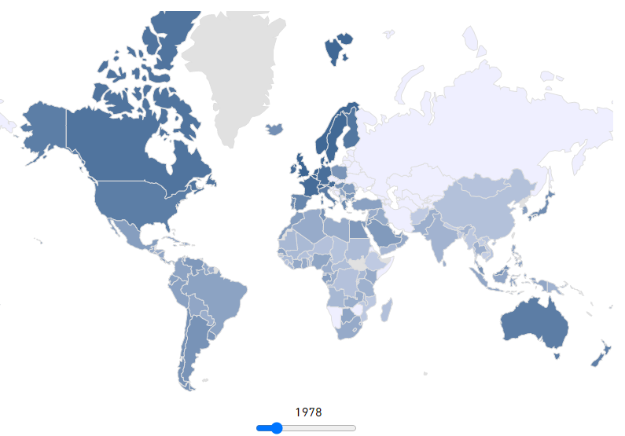
1998 | 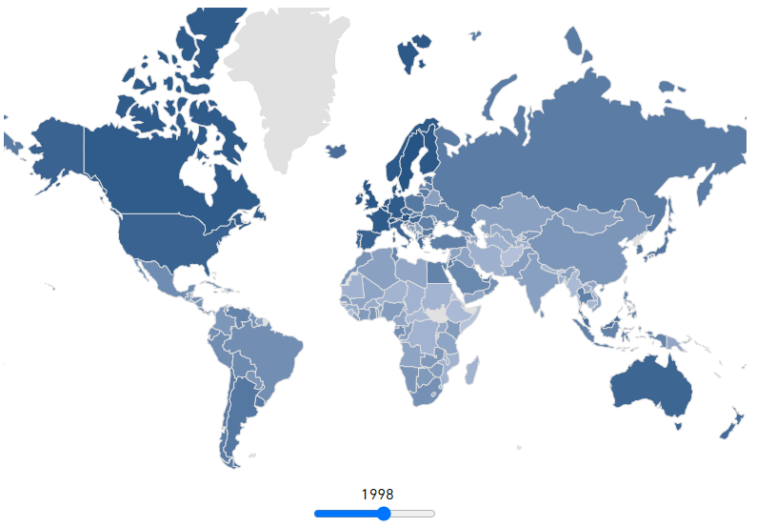
2018 | 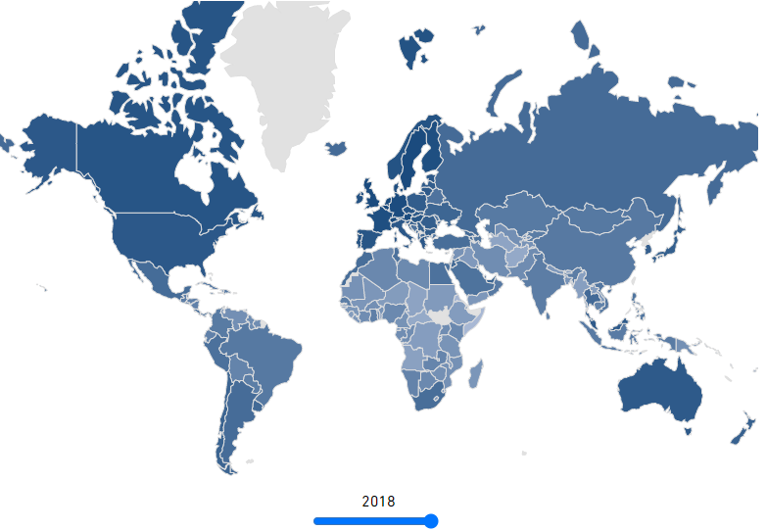

Task 3 – Using the KOF league table and the KOF Press Release available on ibgeographypods as well as the commentary from Task 2, complete a piece of analysis how countries participate in global interactions and how the global KOF map is complex and subject to change.

Task 4 – Did you guess any of the top three most globalized countries? If not, what misconceptions did you have about globalization?

