IB Geography - Human and physical factors & urban tourism hotspots – Venice A3 Sheet
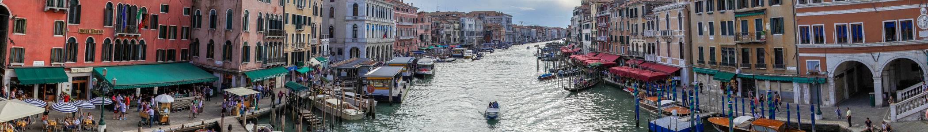
Physical Factor | Evidence from resources | Human Factor | Evidence from resources

Place | Process | Power | Possibility

