IB DP Geography – Dam building for multipurpose water schemes
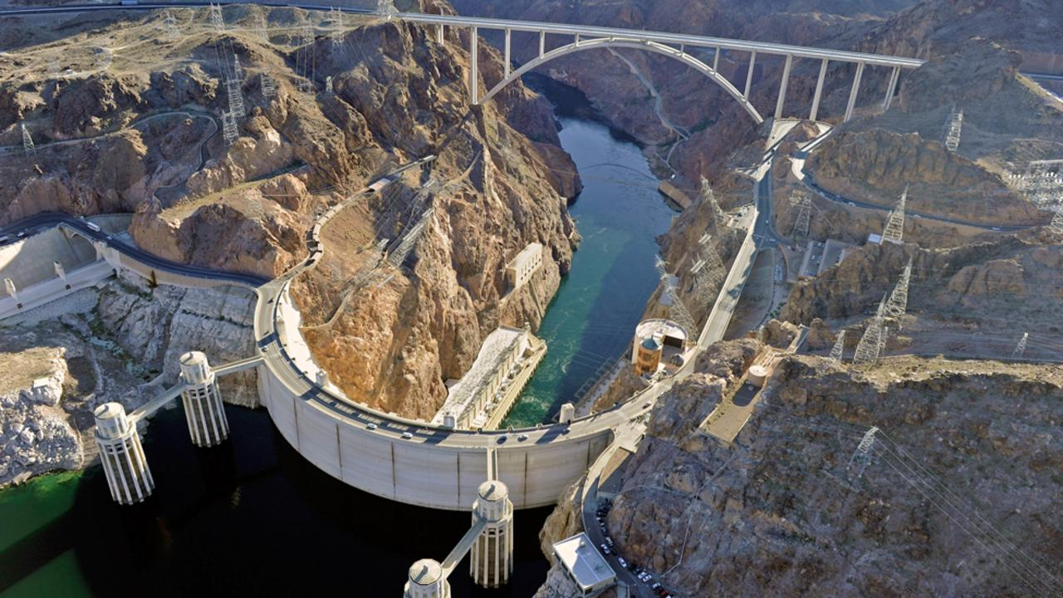
Task 1 - Read Geofile 410 September 2001 and make notes on the generic social, economic, environmental, political and issues (SEEP) surrounding dam construction.
Social | Economic
Environmental | Political

Task 2a – Read the BBC Futures article - Outline the environmental impacts of dams to affected areas.

Task 2b – Using GeoFile Ed 399, April 2001, outline in detail the hydrological changes resulting from dam construction

Task 2c – Outline what has been done in the Grand Canyon by reading and highlighting the 2012 article from the Daily Mail. You may want to add a number of illustrations too.

