Option G Urban Environments – Recognising Siting Factors
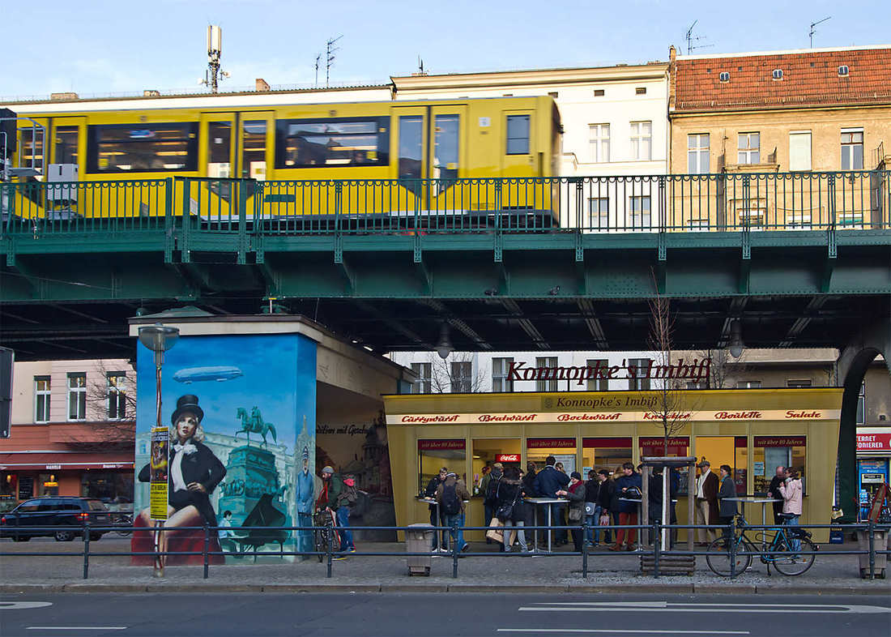
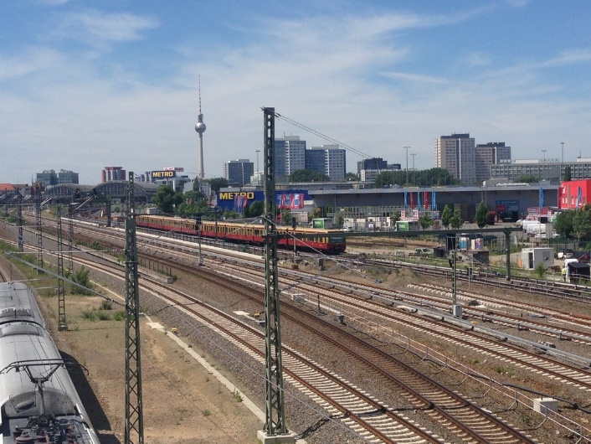
Task 1 – Using the embedded Google Map on ibgeographypods, try to identify as many siting factors as possible for the settlement of Berlin.
Siting Factor | Evidence from map

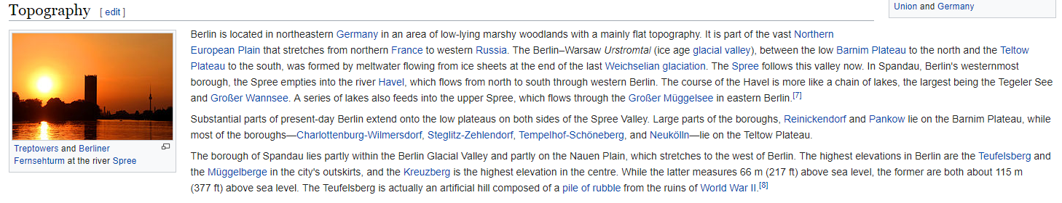

IB DP Geography - Describing Land Use in Berlin
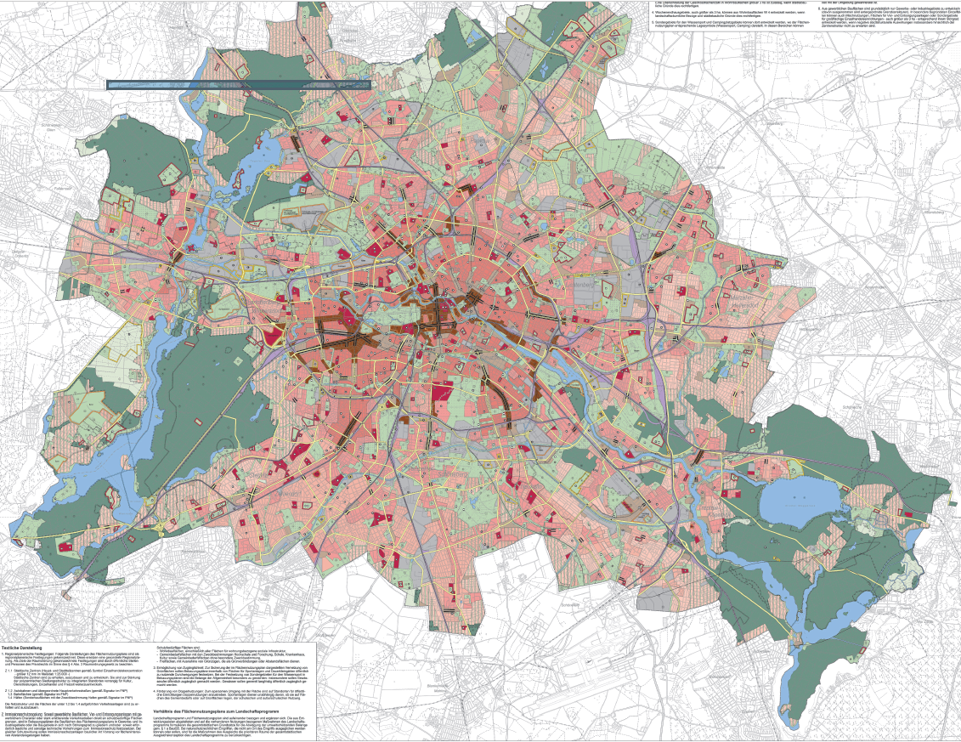

Task 2 – Using the hyperlinked land use map of Berlin on ibgeographypods, describe the land use patterns in Berlin and use the Borough map to the right to help you. Ensure you make reference to:
Residential, Commercial, Retail, Concentrations, Green areas…

