IB DP Geography – Consequences Of Unsustainable Touristic Growth – Rural Hotspot - Machu Picchu
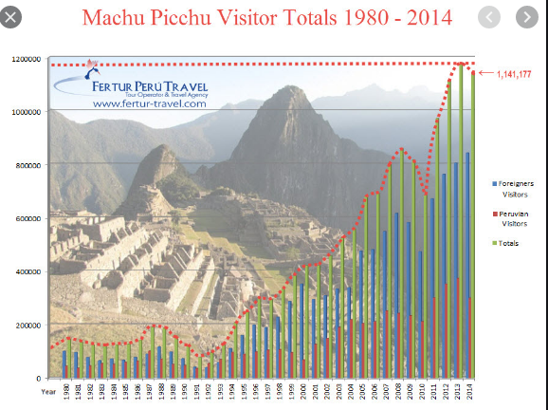
Task 1 – Outline the issues surrounding the carrying capacity of Machu Picchu.
Task 2 – Mark on the location of Machu Picchu and describe its situation below.
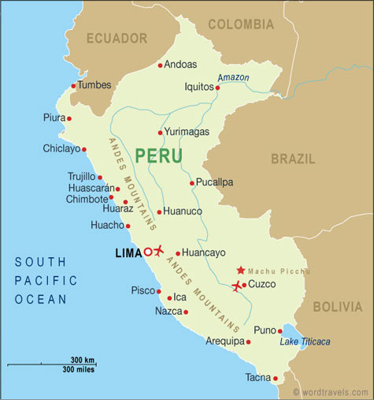

Task 4 – Outline the main features of The Master Plan: Machu Picchu Reconceptualized – Use this link. Continue on the next page.

Task 3 – Study the graph above right and describe the tourism trends shown making reference to foreign and Peruvian visitor numbers. This article will help you.

Task 4 – Continued….

Exam Practice: Referring to one example, discuss the strategies that may be used to manage the carrying capacity of a popular tourist attraction in a rural area (10)

