IB DP Geography - Introduction to drainage basins
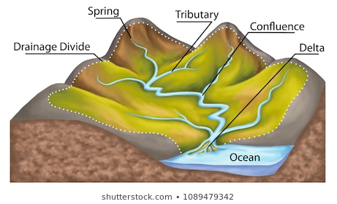

i. What is a watershed/drainage basin?

ii. What are the main functions of a watershed/drainage basin?

iii. How can human action can influence the functioning of the system?

Diagram of closed system
Explanation

Diagram of open system
Explanation

