IB Geography – Introduction to Tourism Hotspots
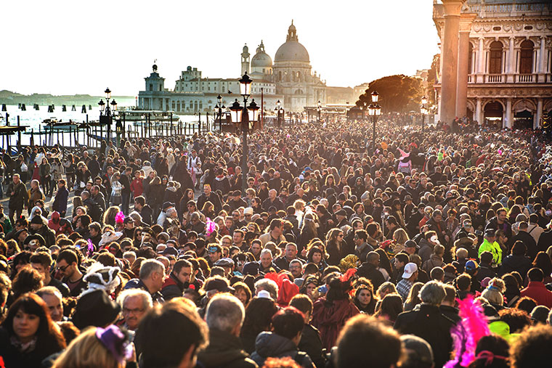
Source - italoamericano.org
Starter Task – Watch the three videos on ibgeographypods and make notes below on the second and third video.
Video 2 | Video 3

Briefly summarise the impacts of tourism on Venice.

Background - The last piece of work in the previous unit demonstrated that tourism and sport can be influenced by a number of physical and human factors.

Physical - Rainforests, mountain ranges, deserts, polar areas, rivers and coasts, climate (hot, dry, cold etc.)

Human - Food & drink, customs and traditions, religion, sporting events, theme parks, architecture etc.

You also saw how tourism can be impacted by global events such as a recession, terror attacks and political instability.

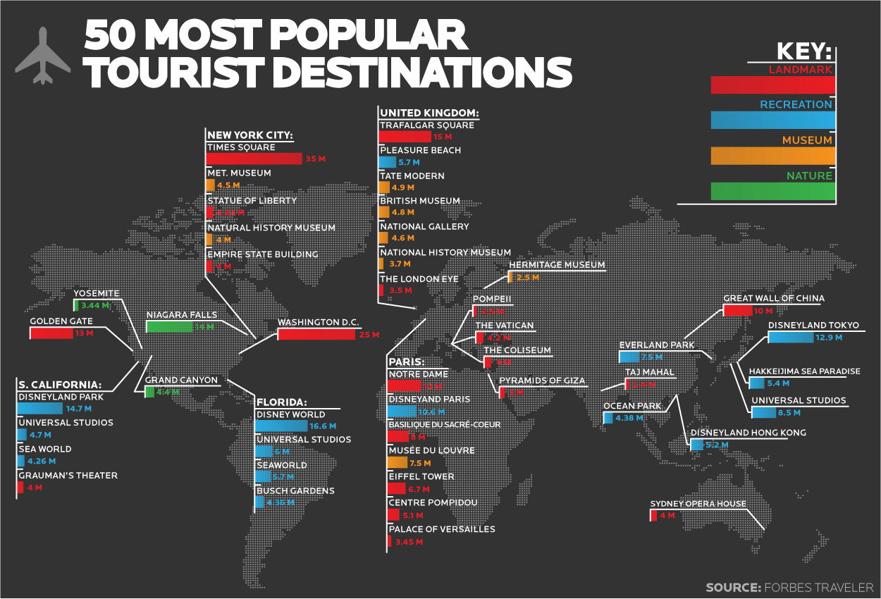
Task 1(i) – Rank the top three visited cities on this map and the total number of visitors.
1
2
3

(ii) - What tourism resource (see key) often attracts the highest number of people?

(iii) - State the three most visited 'resources' in the category above.
Attraction | Number of Visitors | Country

iv. State one weakness of the infographic map.

Task 2 - Using the weblink on ibgeographypods, complete the following tasks.
i. Define a 'Tourist Hotspot'
ii. State the three desirable factors for hotspot creation.
iii. Define and give an example of a seasonal hotspot
iv. Define and give an example of diurnal hotspot.

Task 3 - Where was the last tourist hotpot you visited? How do you know it was a hotspot?

