IB DP Geography – Introduction to Tourism in Iceland
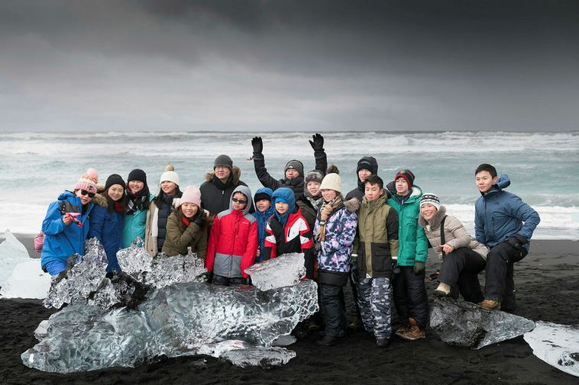
Watch the video embedded on ibgeographypods and complete the activities on this worksheet in response.

What were the original industries in Iceland?
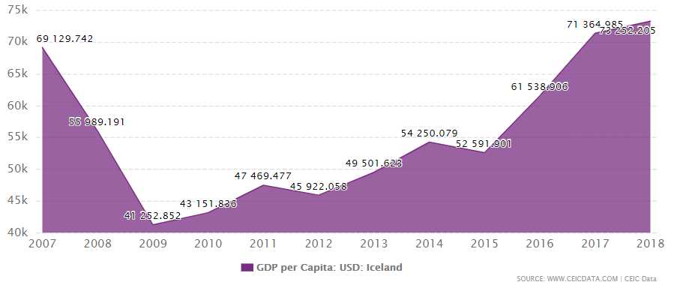

The graph on the previous page shows the growth in Icelandic GDP (per capita) from 2007 to 2018. Describe the trend.

What caused the crash started in 2007?

How did Iceland Air increase tourism numbers in Iceland?

Why did the collapse of the IDK actually lead to the revitalisation of the country?

Annotate around the image below why the eruption of Eyjafjallajökull brought a positive boost to the economy.

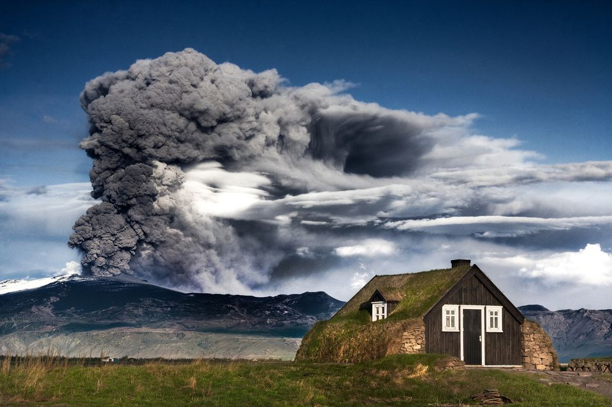

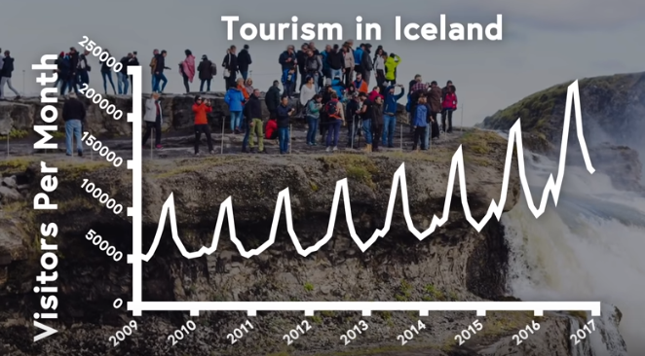
The screenshot from the video above shows tourist arrivals into Iceland from 2009 to 2017. Describe and explain the pattern of tourism during this period. Don’t forget to refer to data from the Y axis.
Describe:

Explanation:

At the peak, how many cities were on a direct flight path from Keflavik airport via Iceland Air & WOW?

Now, pause the video, open Google and research the following attractions in Iceland.
Attraction | Human or Physical | Description of attraction
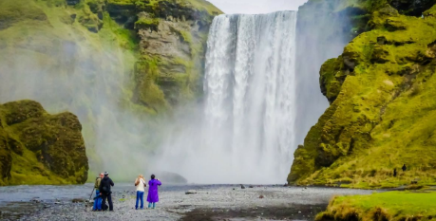

Skogafoss
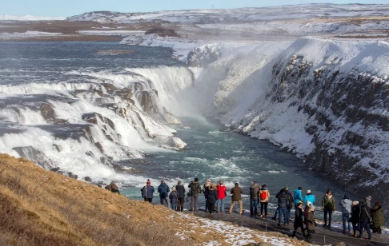
Gullfoss
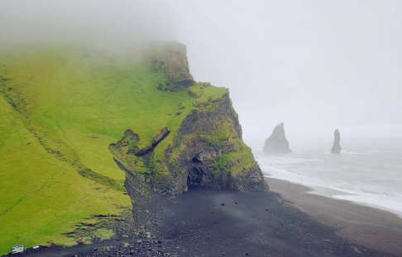
Reynishverfi
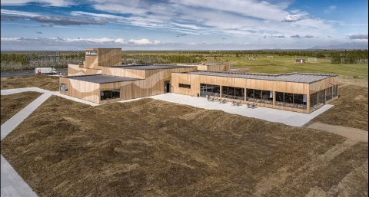
LAVA –
Iceland Volcano &
Earthquake Centre
Exam Corner: Suggest three ways that tourism might create employment for people in Iceland.
1

2

3

