IB DP Geography – Responding to Climate Change – Lesson 1

Turn to page 451 – 452 of the Geography guide and complete the activities beneath.

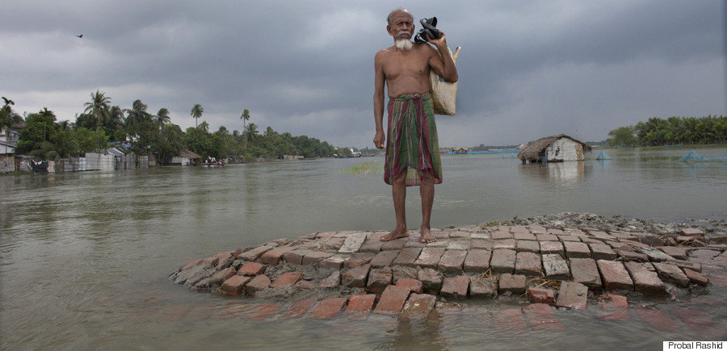

Task 1 - Annotate the picture above with factors that affect the susceptibility of vulnerable populations.

Task 2 - What does vulnerability refer to?

Task 3 – Outline the three main factors associated with vulnerability below.

Task 4 – Using the text, outline who the more vulnerable populations within society may be. Try to explain at least two of these in more detail in the space beneath.

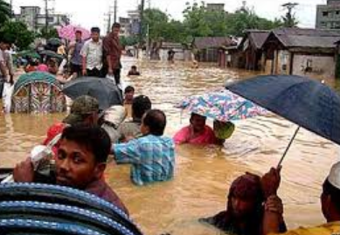

Task 5 – Annotate the map below with the names of the vulnerable nations and potential impacts of sea level rise on those places.

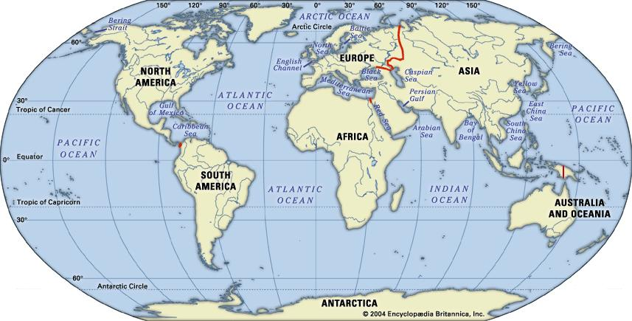

Task 6 – Outline briefly the five issues affecting the places above.
1
2
3
4
5

Climate Change – Impacts on Swiss Ski Resorts
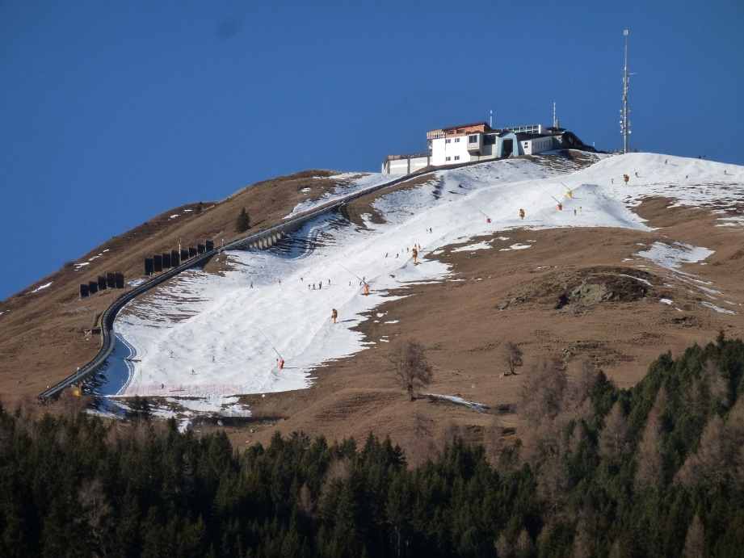
Figure 1 - Source, Carbon Brief.
Task 7 - Use this article to answer to make notes on the following areas
https://www.carbonbrief.org/swiss-ski-resorts-could-see-70-percent-drop-in-snow-cover-as-climate-warms

Task 8 - Outline of possible future climate changes in the Swiss Alps and resultant issues on the industry

Task 9 - “The most affected elevation zone for climate change is located below 1200m, where the simulations show almost no snow towards the end of the century.” – Explain why this is problematic for the Alpine region.

Task 10 - Explain how snow coverage at 1500m may change in an A2 projection.

Task 11 – Using the previous link and this one too (https://www.swissinfo.ch/eng/business/sustainable-approach_what-future-for-winter-tourism-under-global-warming/42934230) outline the impacts of climate change on the resorts, attempts they are making to combat the issues of temperature rise and projected future trends.
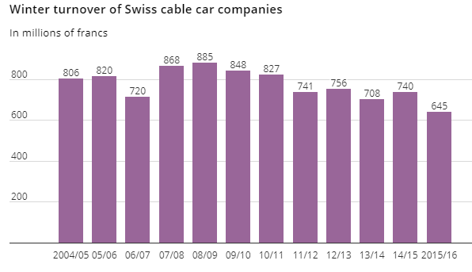
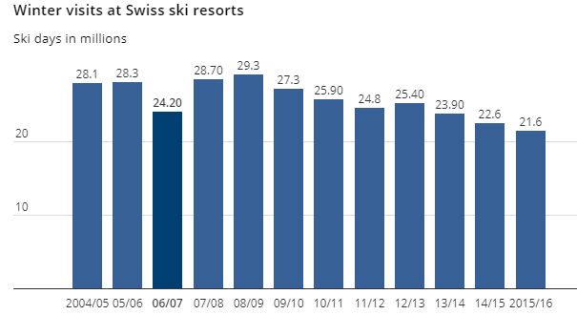

Task 12 – Comment on the trend of both graphs above. To what extent does this justify future tourism developments for the summer season?

Task 13 - Impacts on the Nunavummiut – Northern Canada
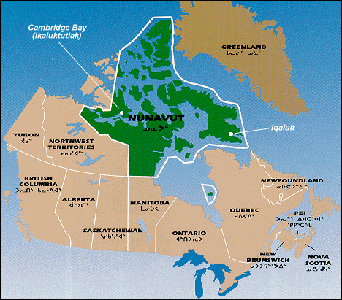
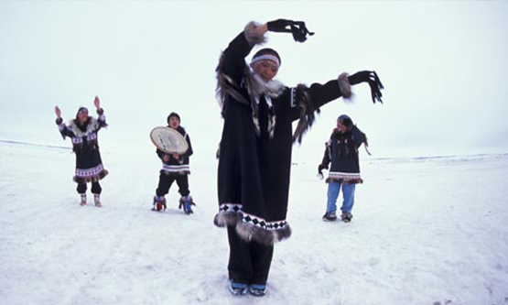
Impacts on Transportation
Use this link to complete activities: https://www.climatechangenunavut.ca/en/understanding-climate-change/climate-change-impact

Impacts on Heritage and Special Places
Impacts on Health and Diseases
Impacts on Traditional Activities
Impacts on cultural identity
Impacts on Food Security

