IB DP Geography – Introduction to the Carbon Cycle
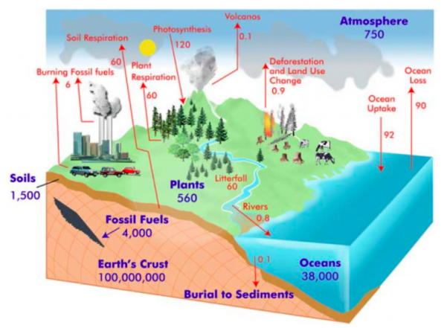
Carbon is also present in the Earth's atmosphere, soils, oceans, and crust. When viewing the
Earth as a system, these components can be referred to as carbon pools (sometimes also called
stocks or reservoirs) because they act as storage houses for large amounts of carbon. Any
movement of carbon between these reservoirs is called a flux. In any integrated system, fluxes
connect reservoirs together to create cycles and feedbacks.

The global carbon cycle above. The blue values are for stores of carbon, while the transfers of carbon between different areas are shown in red. All measurements are in petagrams (1 trillion kg). Source: Global Carbon Cycle Project, 2012.

Outline the functions of the carbon cycle and the relationship necessary for a stable climate.

Outline the three major carbon sinks.
1

2

3

Outline the features of the slow carbon cycle and whether it can be viewed as a major contributing factor to increased CO2 levels in our atmosphere.
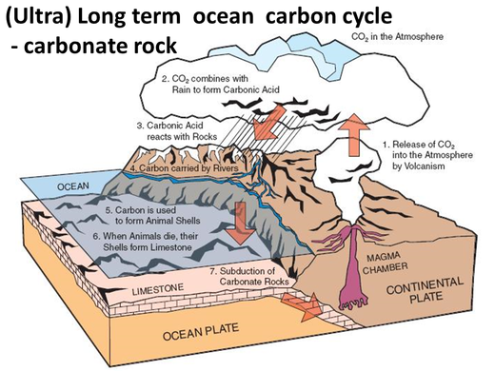

Outline the features of the fast carbon cycle making clear reference to the maps and graphs below.

