IB DP Geography – Climate Change & Severe Weather – Emerging Patterns

Heat Waves | Storms & Flooding | Wild Fires
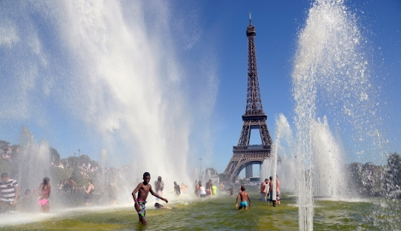 | 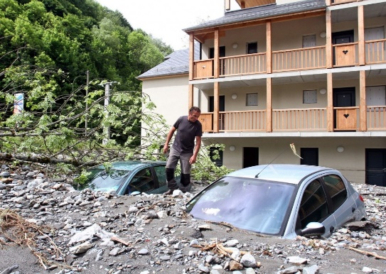 | 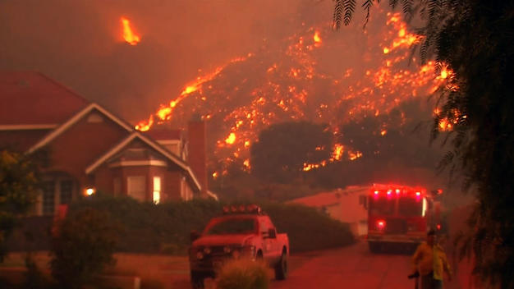
Summary | Summary | Summary
Recent News Event – Heat Wave | Recent News Event – Storm & Flooding | Recent News Event – Wildfires
Place | Place | Place

