IB DP – Geophysical Hazards - Geophysical Hazard Adaptation
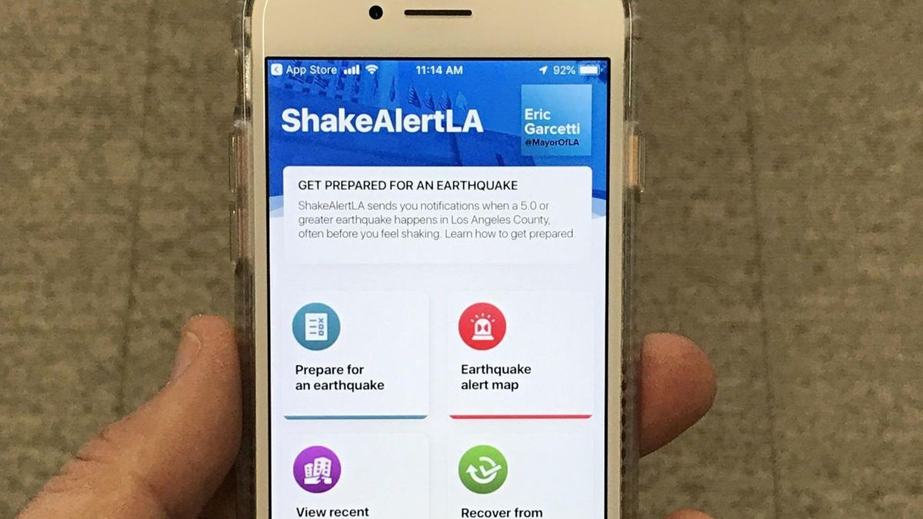
Method 1- Zoning (focus on earthquakes)
How many new people move to urban areas each day around the world?

Explain why there is a global disparity in building code regulations and land use zoning around the world.

Notes on the article – ‘New state map tells you if you live in an earthquake fault zone’

Situation in HICs | Situation in LICs
Authorities use risk maps (earthquakes, volcanoes & landslide) to control land use so as to control damage caused by these hazards. These maps are created using comprehensive data collection using past events, geology & population density. Information is shared with populations at risk. | The control of land is difficult in large urban areas in LICs where rapid rates of rural to urban migration and a lack of resources contributing to the problems. Poverty causes many residents to build their own houses (Haiti) illegally where they may suffer the devastating effects of a geophysical hazard event.

Method 2- Insurance (focus on earthquakes)
Explain the basic principle behind insurance coverage.

How can it be an adaptation strategy?

What are the pros of earthquake insurance?

What are the cons of earthquake insurance?

Situation in HICs | Situation in LICs

Method 3- Technology (focus on earthquakes)
Explain the basic principle behind the application.

How can it be an adaptation strategy?

Benefits & Drawbacks

Situation in HICs | Situation in LICs
High levels of tectonic hazard monitoring in the USA (California). High % of the population has access to Smart Phone technology and therefore can download the application ready for use. The USGS (United States Geological Survey) has one of the most advanced monitoring systems in the world with U.S Government backing of close to $1 billion annually (source)

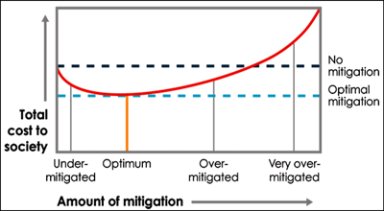
The total cost to society of natural disasters depends on the amount invested in mitigation. The optimal mitigation level minimizes the total cost, the sum of the expected loss and the mitigation cost. In reality, a community is likely to spend less than the optimum, but spending less than the optimum is better than doing nothing. Credit: Stein and Stein [2014]
If we undertake no mitigation, we have no mitigation costs (left side of the curve) but expect high losses, so it makes sense to invest more in mitigation. Increased mitigation should decrease losses, so the curve goes down. Eventually, however, the cost of more mitigation exceeds the reduced losses, and the curve rises again. These additional resources would be better invested otherwise. The optimum mitigation is the best spot at the bottom of the curve.
Uncertainties in our ability to assess hazards and resulting losses limit our ability to determine an optimal strategy. Moreover, given limited resources, a community is likely to spend less than the optimum anyway. Fortunately, spending less is better than doing nothing (Figure 2), and we can still suggest strategies that make sense given the high uncertainty and limited resources.

