IB DP Geography – Infographic Exam Analysis
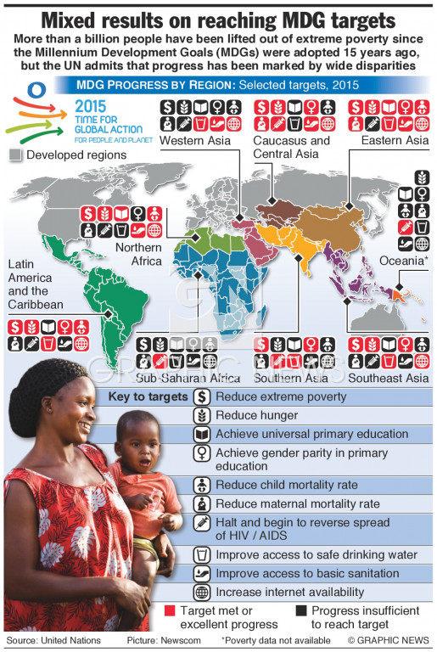

Features | Positives | Negatives
General design

Layout

Readability
Data

Which two regions made insufficient progress in order to meet their target on reducing extreme poverty?

Which region had no data for poverty reduction and why do you think this may be?

