IB DP Geography – Impacts of Climate Change on Severe Weather Around the World.
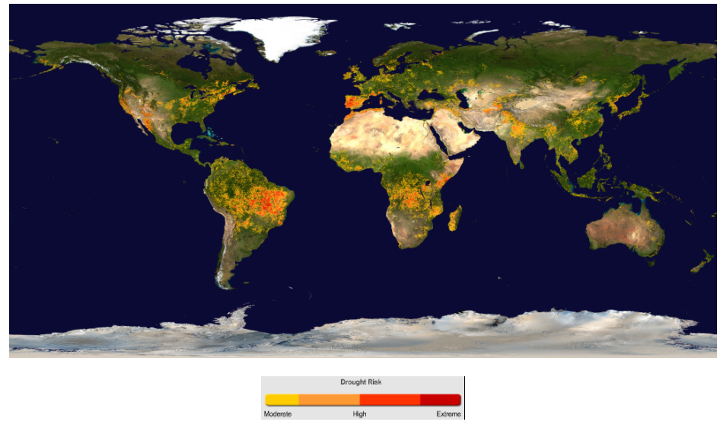
Climate change & California USA (HIC)
Climate change & Burkina Faso (LIC)
Complete Task 2 on geographypods using this A3 notes framework. Note differences in severity between HIC, MIC & LIC.
Climate change & drought in Brazil (MIC)

