IGCSE Geography – Processing your Berlin Data

Download and save the results recording sheet from geographypods. You will then need to enter all of your data from your results booklets for your chosen zones. If you have not chosen four zones, add three more columns to each data table to record all your zones and then decide afterwards.
Perception Survey:
There are a number of ways to show this but the best is perhaps a mixture of photographs and a radar chart. To do this, highlight the data you want to include (for example all positive data for all four areas) and then click on ‘insert’ and ‘recommended charts’. On the top tab, click on ‘all charts’ and then select either radar or ‘sunburst’. Of course, you can do a plain old bar chart but it doesn’t show the differences between the areas as well.
Individual radar charts can be also produced for each chosen study area. These could then be stuck onto a map to create a located radar chart.
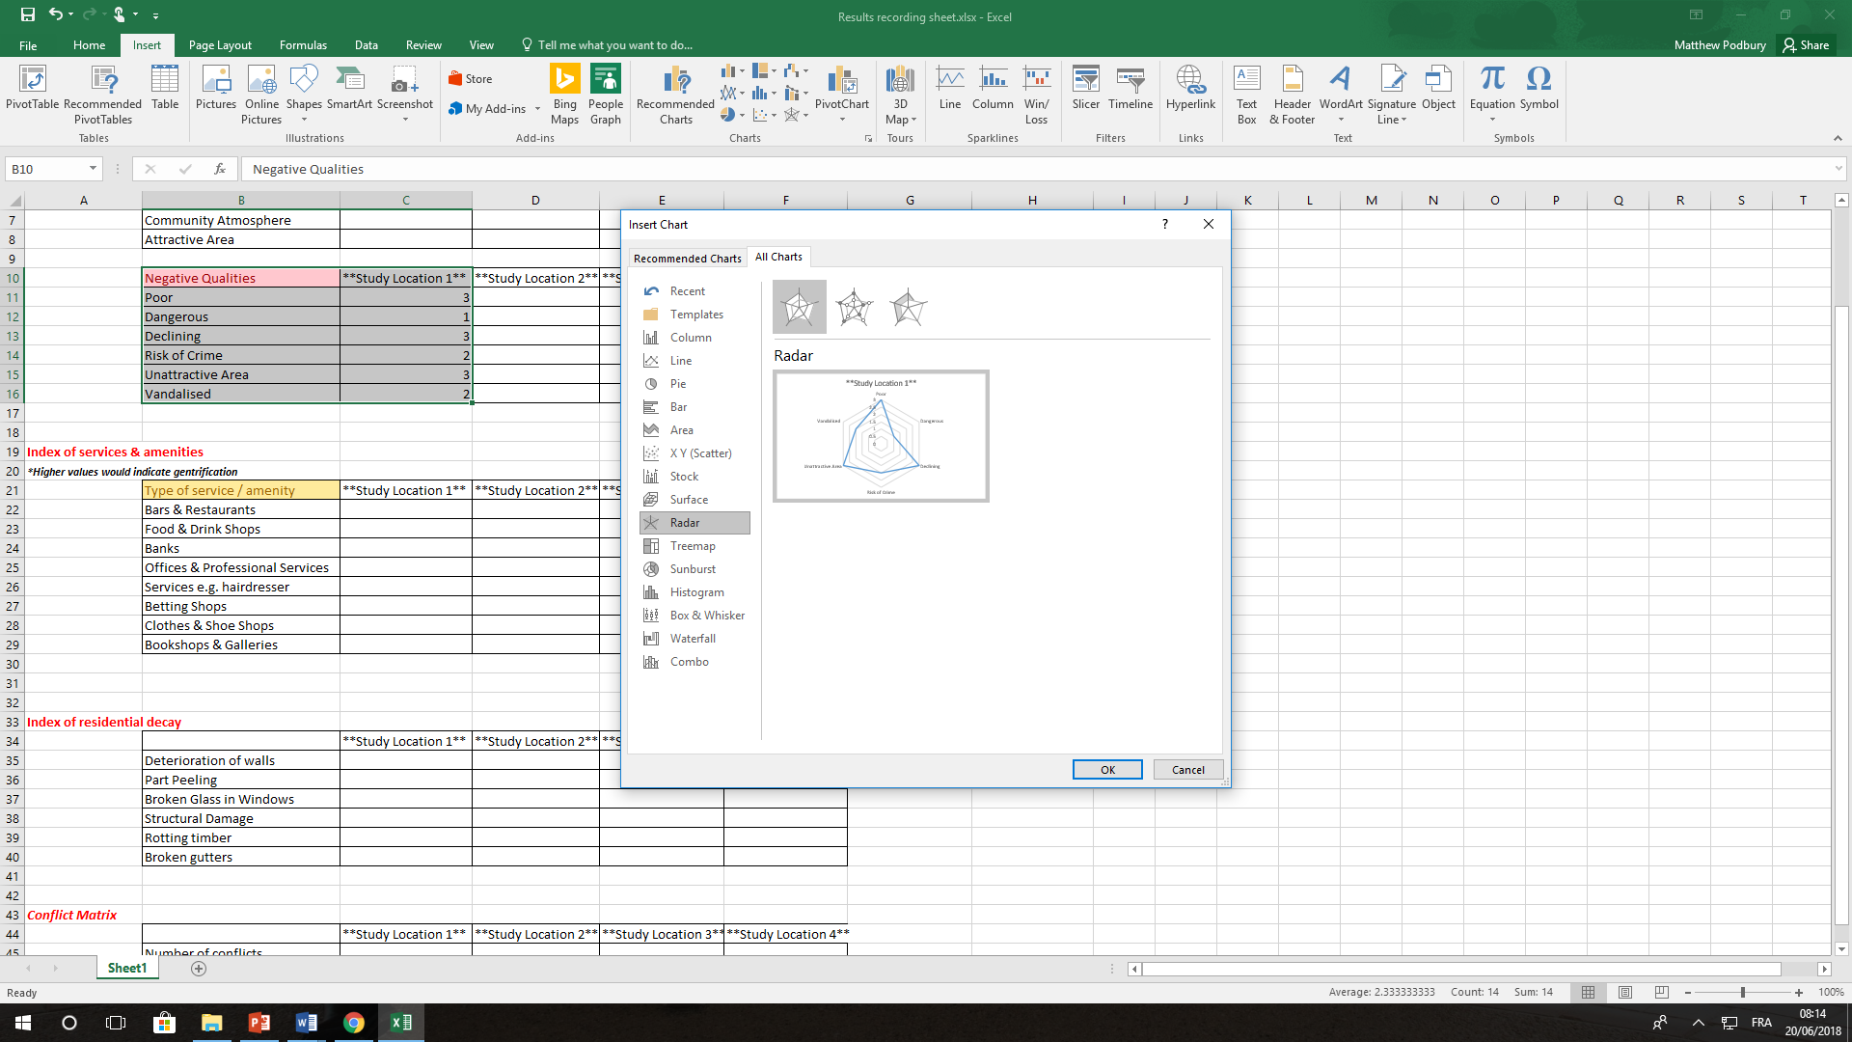

Index of services & amenities
You have a number of ways that you can show this. Remember that the higher the value, the more likely that gentrification as a result of tourism has occurred. Perhaps bar charts, another radar chart etc? Again, this could also be turned into a located chart using a map to show distribution of data.

Index of residential decay
This can be shown through a mixture of annotated photos and can be graphed out again using the data in your table in an imaginative way. Remember these results will indicate to you whether an area has been improved (high scores) or not (low scores) and should link in to perception survey.

