IBDP Geography – Integrated Drainage Basin Management Plans (IDBM) – Back to Murray Darling!
"Integrated river basin management (IRBM) is the process of coordinating conservation, management and development of water, land and related resources across sectors within a given river basin, in order to maximise the economic and social benefits derived from water resources in an equitable manner while preserving and, where necessary, restoring freshwater ecosystems”.
Outline the users of the DB | What were the modifications that were inflicted on the DB?
What were the resultant stresses that were inflicted on the DB? | 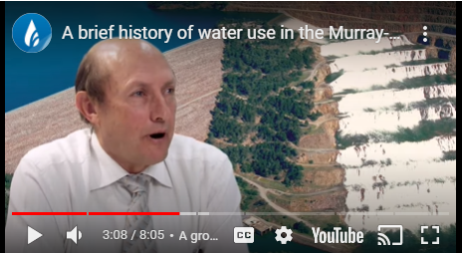
Integrated drainage basin management creates the possibility of sustainable development for different stakeholders.
Part 1 of 3 - The history of the plan | Part 2 of 3 - Governments act | Part 3 of 3 - Basin Plan
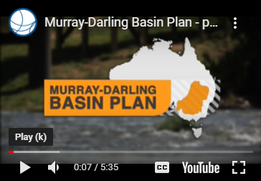 | 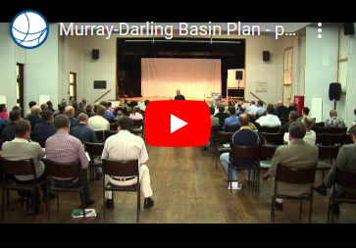 | 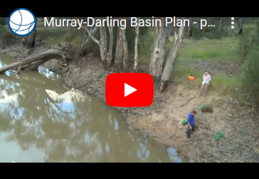
Notes | Notes | Notes

Watch the final video and make notes about the disadvantages of the plan on the Murray Darling Basin. You need to appreciate another perspective for an ‘analyse’ question.

