|  |
| --- |
| **IBDP Geography - Political, economic and cultural factors affecting the hosting of hosting the 2012 Olympics** |

The modern Olympic Games or Olympics (French: Jeux Olympique’s) are the leading international sporting events featuring summer and winter sports competitions in which thousands of athletes from around the world participate in a variety of competitions. The Olympic Games are considered the world's foremost sports competition with more than 200 teams, representing sovereign states and territories, participating. The Olympic Games are normally held every four years, and since 1994, have alternated between the Summer and Winter Olympics every two years during the four-year period. Their creation was inspired by the ancient Olympic Games, held in Olympia, Greece from the 8th century BC to the 4th century AD. Baron Pierre de Coubertin founded the International Olympic Committee (IOC) in 1894, leading to the first modern Games in Athens in 1896. The IOC is the governing body of the Olympic Movement (which encompasses all entities and individuals involved in the Olympic Games) with the Olympic Charter defining its structure and authority.

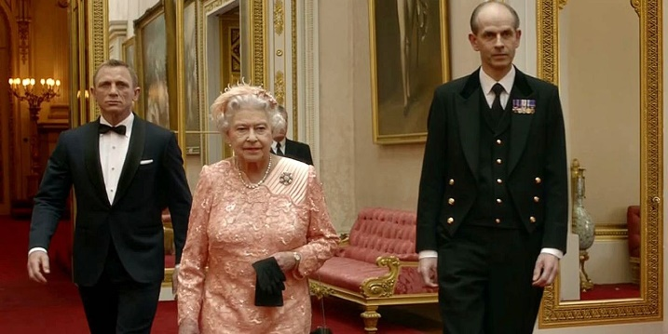

**Selling the UK as a great place to visit.**

Task 1. What cultural image was Britain and specifically London trying to portray to the rest of the world in the two ceremonies watched by billions of people worldwide?

Make notes under the following subheadings:

a. History – Winston Churchill statue waving

b. Landmarks – Buckingham Palace, Trafalgar Square, Big Ben, Houses of Parliament. Tower Bridge, London Eye.

c. Film – James Bond

d. Music – Dam Busters & James Bond theme

e. Business – There are people of different ethnicities (potential business partners)

f. Humour – Corgis

Fact box

London Olympics 2012

Dates :

Total Cost :

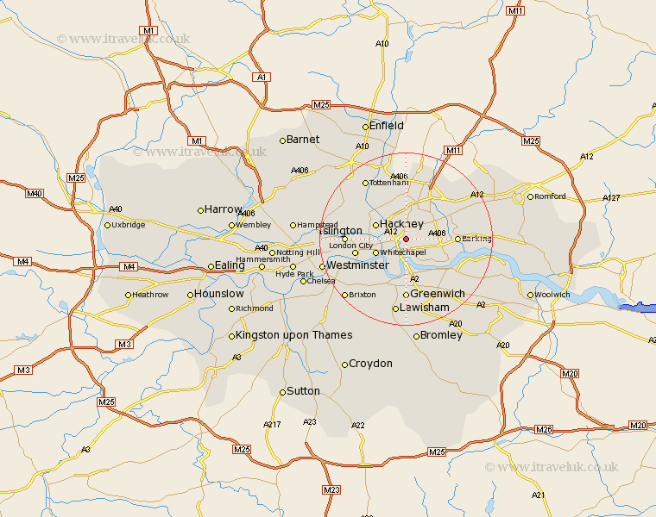

Write a description of the site and situation of Stratford within the conurbation of London.

The stadium is in the East of London. It is north of the river Thames and 11 km northeast of the centre of London.

**Task 2** - The socio-economic change that an Olympics brings to a city. Make notes on what Stratford used to be like and why the area was ripe for redevelopment.

* It is an industrial area, with many factories.
* The rivers have a lot of vegetation on either bank, with trees.
* There is now less crime.
* The canals are less polluted than they were.
* They had to build on greenfield land, making it very expensive.

**Task 3** - Why is a strong economy such as that of Great Britain an important geographical factor when deciding on a host country's ability to host such a prestigious event?

**Task 4** – Political – Take notes here on why London 2012 is seen as a good opportunity for a bit of soft power!!

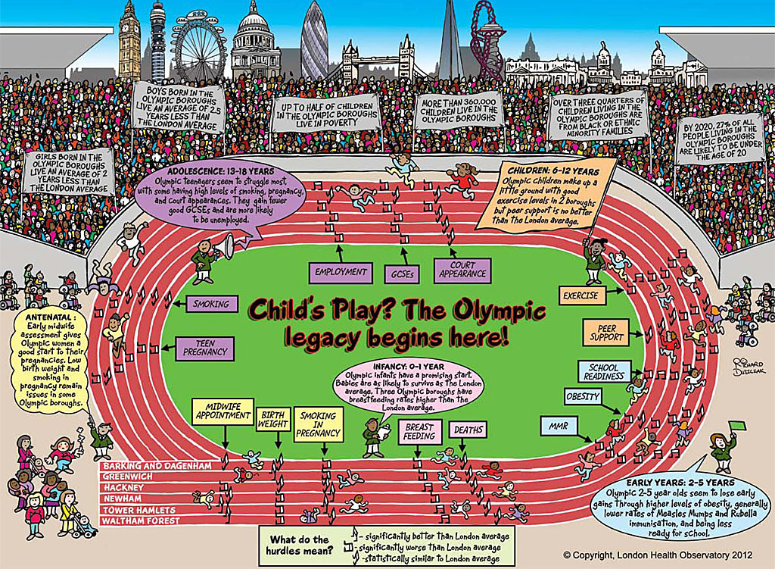

**Task 5** - Legacy –Take notes from the Sky News 6 minute report here and the interview video with the local resident.