IB DP Geography – Global Patterns & Classifications of Economic Development

Threshold | Value range $  2020 | GNI per Capita ($) | Country Example  (Guess) | Country Example  (Correct)
Low-income
Low-middle income
Upper-middle income
High income

Task - Complete the table above using the table on ibgeographypods.
Task - Below you will see three maps tracing the pattern of economic development over time. The link to the interactive site where you can click on countries to find out their GNI per capita is on the website & correct your table above. Complete a piece of summary writing for each map in the space provided underneath.
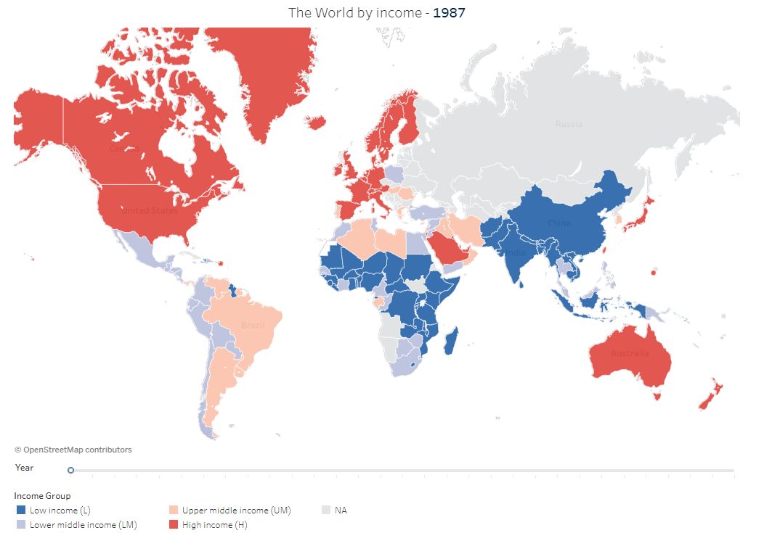

Summary of income distribution in 1987.
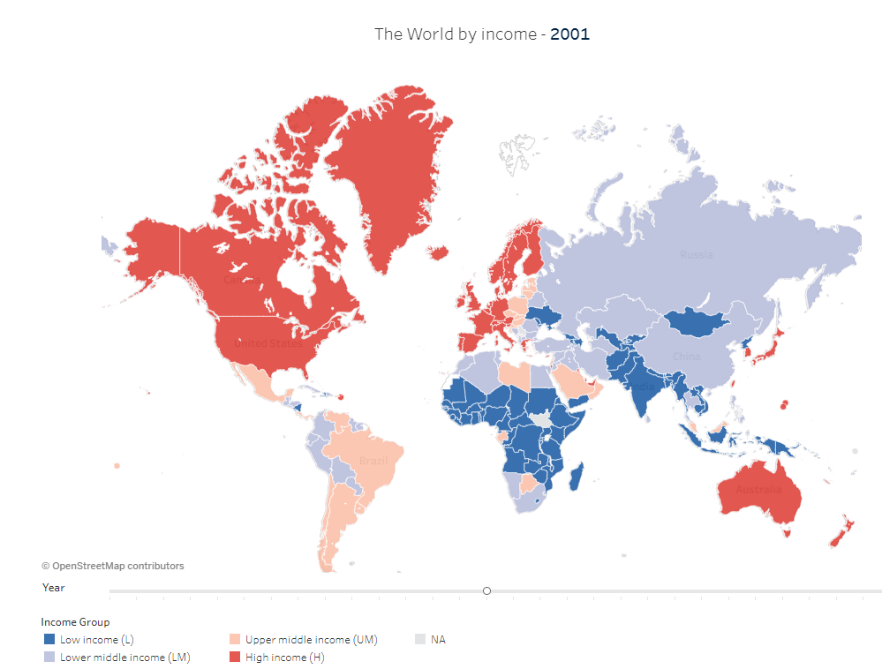

Summary of income distribution in 2001 & changes from 1987.
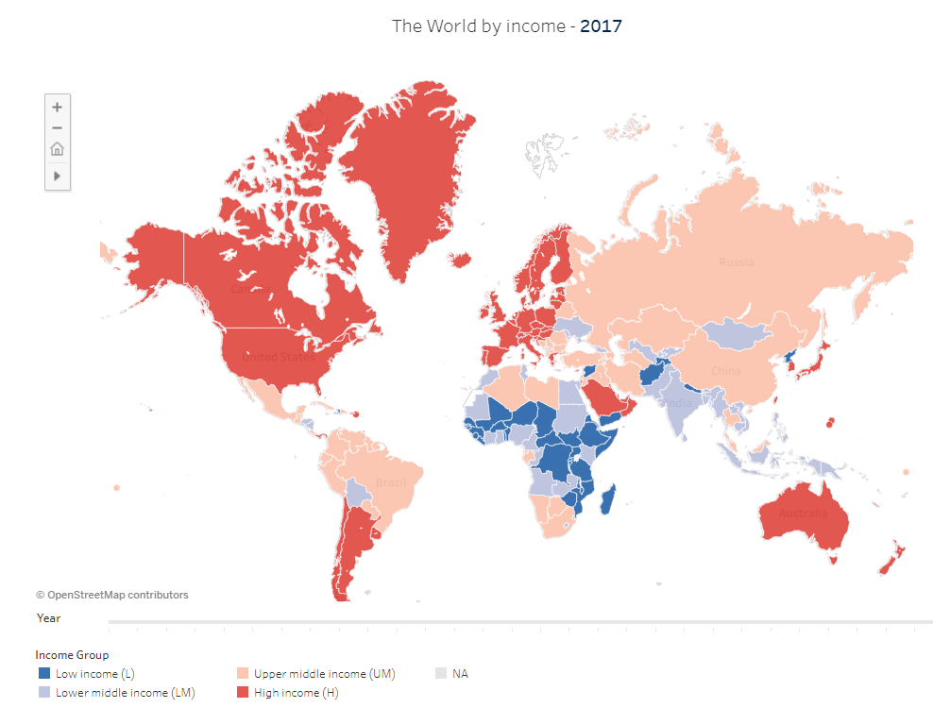

Summary of income distribution in 2017 & changes from 2001.

TOK talking point – Identify one problem with the World Bank maps above.

GNI per capita is measured by dividing the countries gross national income by its mid-year population. Give one drawback of using this unit when measuring development.

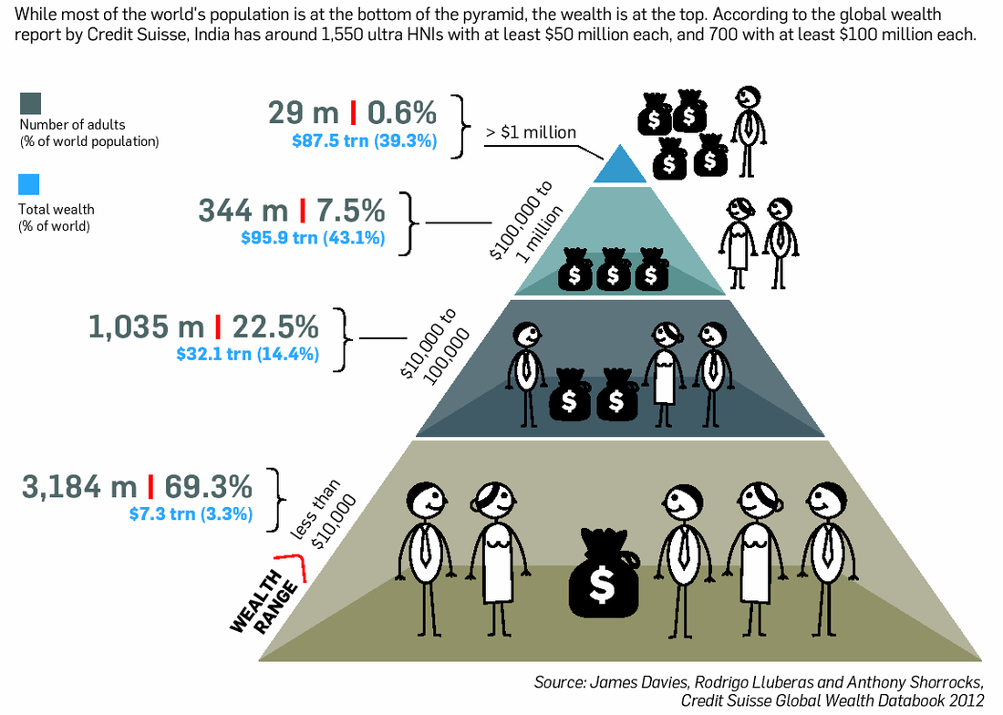

Study the infographic above and complete the following questions:

- State the total wealth percentage shared by the richest percentage group on the infographic.

- State the total combined wealth of the world.

- Suggest one improvement to the infographic.

