IB DP Geography – The Gender Inequality Index (GII)
The Gender Inequality Index (GII) is an index for measurement of gender disparity that was introduced in the 2010 Human Development Report 20th anniversary edition by the United Nations Development Programme (UNDP). According to the UNDP, this index is a composite measure to quantify the loss of achievement within a country due to gender inequality. It uses three dimensions to measure opportunity cost: reproductive health, empowerment, and labor market participation (Wikipedia)
Using the link on ibgeographypods, take some further notes on how each dimension is measured.
Reproductive Health

Empowerment

Labour Market Participation

How is the gender inequality index calculated?
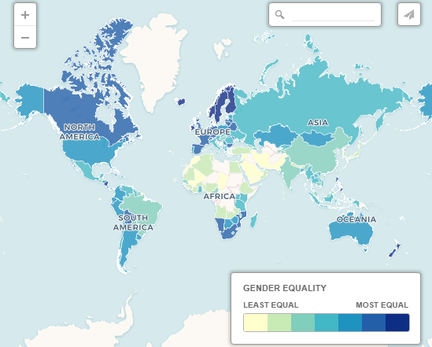

Study the map above (also embedded on ibgeographypods) and comment on the pattern of gender inequality globally. Make a note of the top and bottom 3 countries globally.
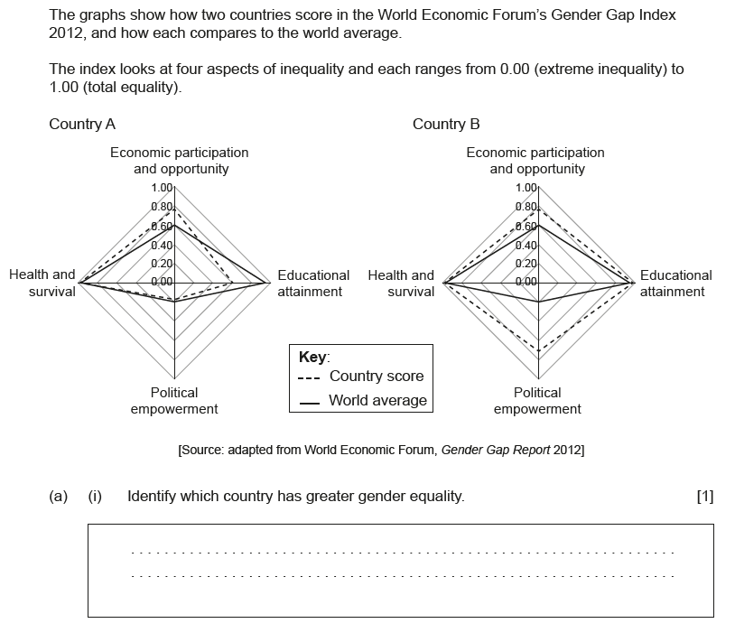

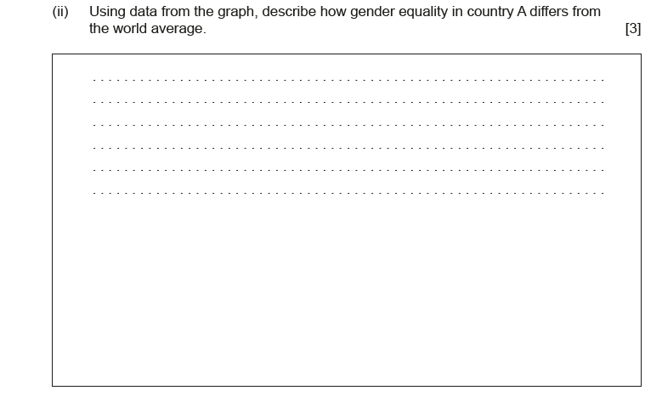

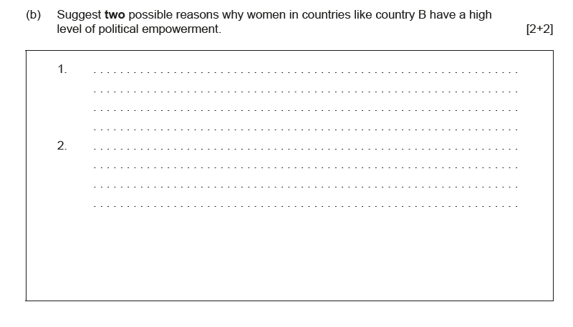

Source: IB DP Geography Paper – November 2015

Using the link on ibgeographypods, make notes on the limitations of GII.

More on Goal 5
