IB Geography – Hazards & Disasters
Case Study Summary Sheet for Ponzano Landslide, Italy (HIC)
Where did it happen?
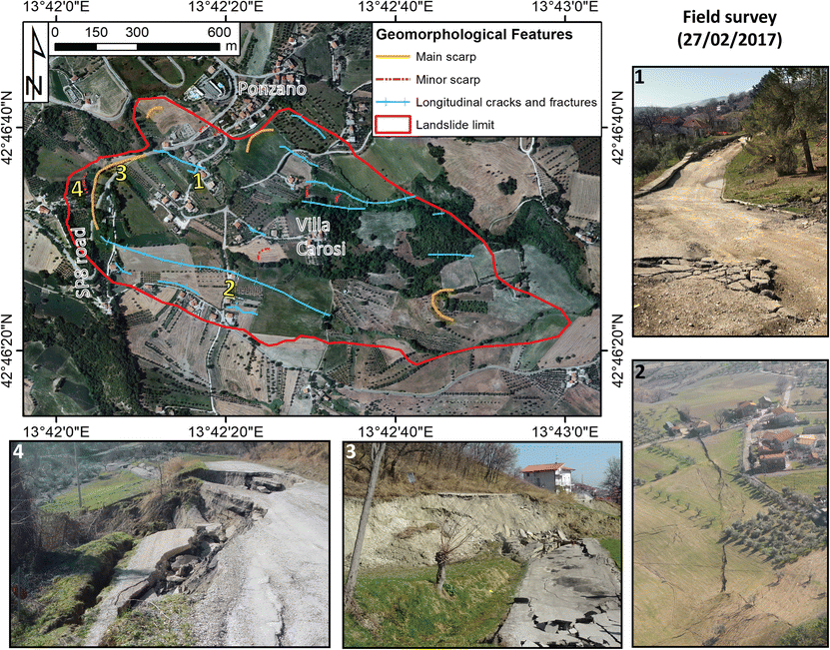
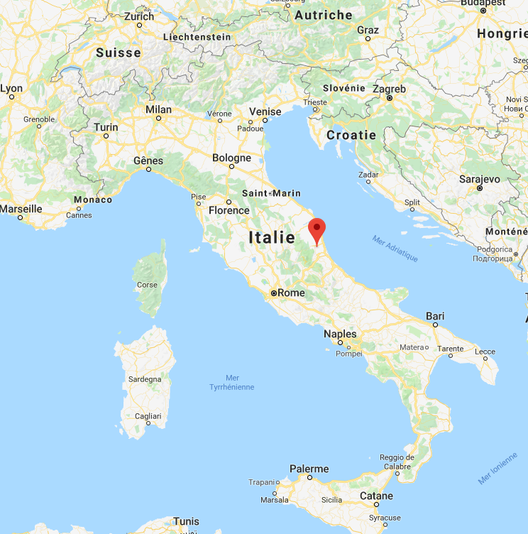
Ponzano is a small village found in the Abruzzo region of Southern Italy. It has a population of 200.

Geo Fact Box – Italy Need To Know
Indicator | Values (2010 estimated)
GDP per capita PPP | $32000
People Living in Poverty (less than $2 per day) | 2% of the population
Access to Clean Water | 99% of the population
Life Expectancy | 83 years
Literacy Rate | 99%
People Per Doctor | 4.2 doctors per 1000 people

When did it happen?
Date. 12 Feb 2017
Duration. The landslide, which was reported to me moving at about one metre per day for almost two weeks
Why did it happen?
The landslide, with an estimated volume of about 7000000 cubic meters, was triggered by the combination of two factors: i) saturation of the slope after the direct and slow infiltration of water related to 2 metres of snow melting due to the increase of temperature between the end of January 2017 and the beginning of February 2017; ii) intense rainfalls recorded, between 6th and 10th February 2017 with a cumulative value of 81 mm, representing the 93% of the total rainfall of February 2017.

Who was affected by it happening?
Social Impacts | Economic Impacts
More than a hundred people have been evacuated from 35 different houses.  Several buildings have already collapsed or sustained severe damage  Evacuated residents are staying at local hotels or with friends and family members.  Losses minimized to the slow moving nature of the landslide. People were evacuated in good time by the authorities. | Limited due to small population of the area.  Losses to 35 properties.
Environmental Impacts | Political Impacts
Agricultural area surrounding the village deemed unsafe due to the possibility of further movement. | Civitella del Tronto town hall said that it was not possible to stop the landslide in any way and that the damaged houses are no longer fit for use and are destined to collapse.  Italy's Civil Protection Department and National Research Council have set up monitors in the village to track the movement, while firefighters are in place to help villagers recover belongings from their abandoned homes.  The local health authority has also sent teams of psychologists to assist evacuated people.

Impacts of these hazards on different aspects of human well-being
Health | Shelter
Food | Water

