IB DP Geography – Factors affecting flood risk
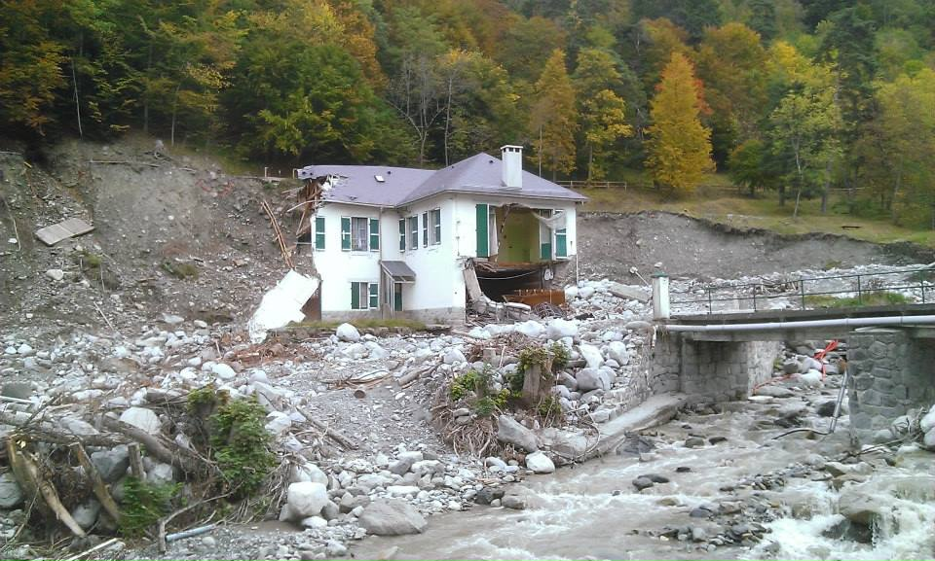
1 - Bareges, France 2013. M Podbury
Task 1 – Using the resources on the impacts of urbanization on flooding, complete the table below.

Outline the issue here & include example of place.
Effects on distribution of flood event | Effects on frequency of flood event | Effects on magnitude of flood event

Task 2 – Using the resources on the impacts of deforestation on flooding, complete the table below.

Outline the issue here & include example of place.
Effects on distribution of flood event | Effects on frequency of flood event | Effects on magnitude of flood event

Task 3 – Using the resources on the impacts of channel modification on flooding, complete the table below.

Outline the issue here & include example of place.
Effects on distribution of flood event | Effects on frequency of flood event | Effects on magnitude of flood event

