IB Geography – Hazards & Disasters
Case Study Summary Sheet for Eyjafjallajökull Eruption 2010 (HIC)
Where did it happen?
Eyjafjallajökull is one of Iceland's smaller ice caps located in the far south of the island of Iceland. Situated to the north of Skógar and to the west of the larger ice cap Mýrdalsjökull, Eyjafjallajökull covers the caldera of a volcano 1,666 m high, which has erupted relatively frequently since the last ice age. The volcano beneath lies on the convergence zone of both the North American and Eurasian plates on a constructive plate boundary (see first map below).
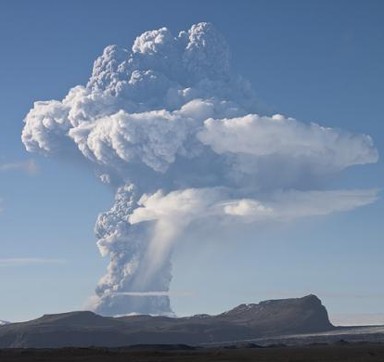
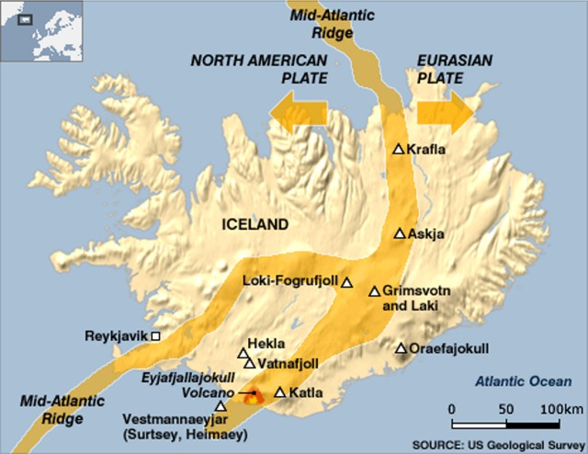

Geo Fact Box – Iceland Need To Know
Indicator | Values (2017 estimated)
GDP per capita PPP | $70,000
People Living in Poverty (less than $2 per day) | 0% of the population
Access to Clean Water | 100% of the population
Life Expectancy | 82 years
Literacy Rate | 100%
People Per Doctor | 1.2 doctors per 1000 people

When did it happen?
Date. 14-20 April 2010 saw the most active eruptions and emissions of gas and ash. By 20th May, the activity had calmed to such as point that no material was detected being ejected from the volcano.
Duration. Eruption was declared officially over on 20th October 2010, six months after it started.

Why did it happen?
Small eruptions began in March 2010 as lava and ash was ejected from the volcano. Volcanologists were not surprised as Iceland is tectonically active but were worried that it could be part of a larger series of eruptions leading to the eruption of Katla – potentially the most destructive volcano on Iceland. Iceland lies at the junction of two major plates. The North American and Eurasian plates are pulling away from one another and volcanic eruption is common. April 14-20 saw fissures opening up in the ice sheet with lava pouring out, melting the ice cap and causing river levels to rise considerably. Additionally, volcanic material was ejected high into the jet stream and grounded thousands of flights over Western Europe and the Atlantic for many days.
Who was affected by it happening?
Social Impacts | Economic Impacts
No fatalities were recorded.  Some reports of respiratory issues among residents most impacted by the eruption plume.  500 farmers evacuated from surrounding area.  Volcano tourism" quickly sprang up in the wake of the eruption, with local tour companies offering day trips to see the volcano | The thick layer of ash that had fallen on some Icelandic pastures and farms had become wet and compact, making it very difficult to continue farming, harvesting, or grazing livestock.  Flights were grounded to and from Reykjavik disrupting the import of supplies as well as flows of tourists.  The second phase of the eruption occurred beneath glacial ice. Cold water from melted ice quickly chilled the lava, causing it to fragment into highly abrasive glass particles that were then carried into the eruption plume. This, together with the magnitude of the eruption, injected a glass-rich ash plume into the jet stream.  In addition to volcanic ash being very hazardous to aircraft, the location of this eruption directly under the jet stream ensured that the ash was carried into the heavily used airspace over northern and central Europe.
Environmental Impacts | Political Impacts
Ash covers pasture and impacts on biodiversity.  The additional ash particles in the atmosphere increase temporarily levels of albedo.  Flash flood event and rapid heating of river water (+6° in 2 hrs.) caused by rapidly melting ice sheet. This water raced downstream causing widespread damage to the river channel and banks. | A very high proportion of flights within, to, and from Europe were cancelled, creating the highest level of air travel disruption since the Second World War.  The Civil Protection Department was deployed in order to control access to and from vulnerable communities and to keep people away from the flood plains that could be inundated with meltwater.

Impacts of these hazards on different aspects of human well-being
Health | Shelter
Food | Water

Why levels of vulnerability varied both between and within communities
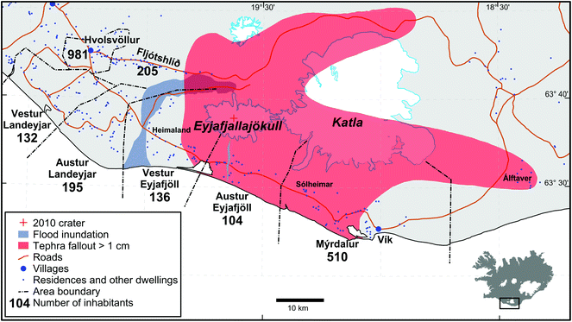

Comment on the distribution of affected population around the volcano & those affected by the tephra (ash) fallout as well as flooding.

Explain why there were no residences / other dwellings affected by the secondary flood event generated by the eruption.
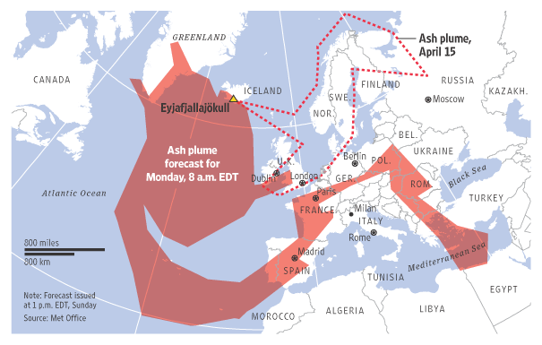

Study the image above carefully showing the extent of the ash cloud across Europe directly after the first explosive eruptions. Explain how populations who lived far from Iceland were also vulnerable to this secondary hazard event.

Using this link, outline how levels of vulnerability can be reduced by improving levels of personal knowledge and preparedness. You may want to use the graphic below from the Iceland Government too.
